Analog and Digital 2

Assignment

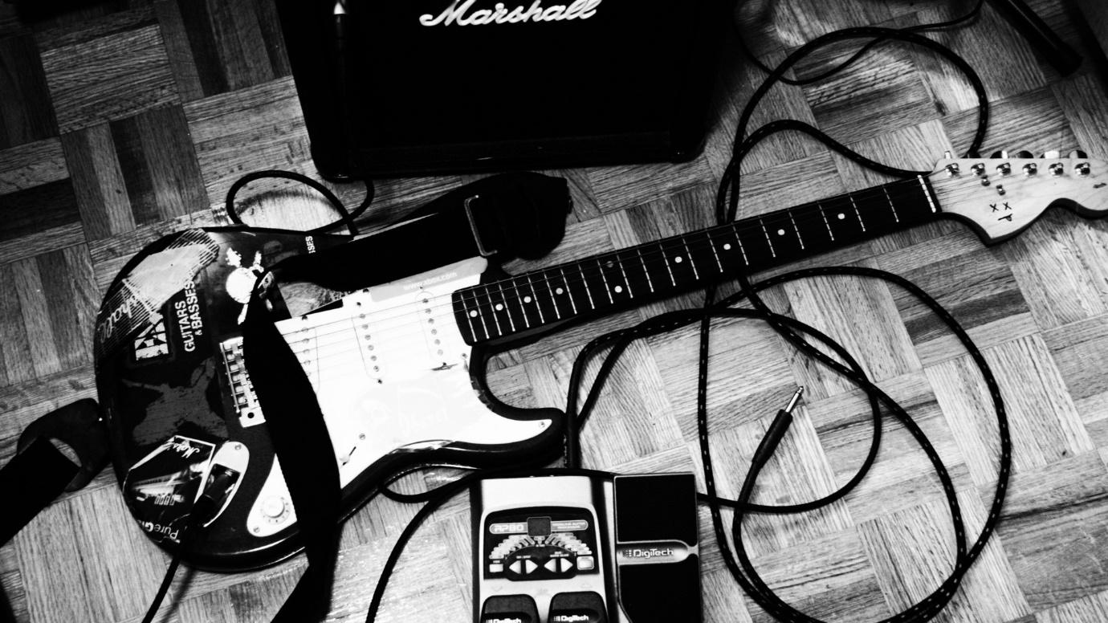

**[1]**

By Ben Edwards: 18026826

# Table Of Contents

Introduction………………………………………………………………………………………...pg. 3

Figures…………………………………………………………………………………………………pg. 4

Part-A Pg.4

Part-B Pg.12

Part-C Pg.24

Tables…………………………………………………………………………………………………. pg. 27

Part-A Pg.27

Part-B Pg.27

Part-C Pg.28

Main body……………………………………………………………………………………………pg. 32

Part-A Pg.32

Part-B Pg.37

Part-C Pg.44

Conclusion……………………………………………………………………………………………

Part-A Pg.37

Part-B Pg.44

Part-C Pg.46

References……………………………………………………………………………………………pg. 47

# Introduction: -

## Part-A

For this assignment, I have been tasked with building and simulating a class A and class B amplifier in the circuit simulation program called multisim. Using multisim I will be able to conduct multiple tests of the amplifiers by varying the input voltage and the frequency, recording my results along the way. I will then produce a report for both class A and class B that will contain the gain, the similarity of theoretical and practical values and the overall operation of the circuit, discussing the difference between the two amplifiers.

For the final task of part A, I will need to build a physical circuit of a class A amplifier using the 2N4401 transistor, producing a report on the gain. I will then need to compare the similarity of theoretical and practical values, relating my finding back to the class A amplifier circuit I simulated in multisim.

## Part-B

Part B will consist of a series of simulations that will involve the use of multisim to simulate the effects of a passive high and low pass filters. The cut-off frequency and the gain will be calculated while also measuring the output voltage and the bode plot, to find the half power point and phase shift at the -3db point, of the filter circuit using a series of input values and frequencies. The theoretical values for all the outputs would then need to be calculated and compared to the recorded practical values to gather a deeper understanding of the effects taking place.

For the active band pass filter circuit, the cut-off frequency and the gain for the non-inverting amplifier would need to be calculated and applied to a circuit simulation in multisim. Measuring the output voltage and bode plots, finding the half power point and phase shift at the -3db point.

## Part-C

For this final part of the assignment, a vending machine state machine is required to be designed and its logic gate circuit drawn in multisim. This state machine will have three inputs only, representing the values of the £2, £1, and 50p coins. The vender won’t be able to dispense any change however, so after completing this task a list of improvements to the circuit design can be made including more features and improving on what’s already there.

# Table of Figures: -

## Part A

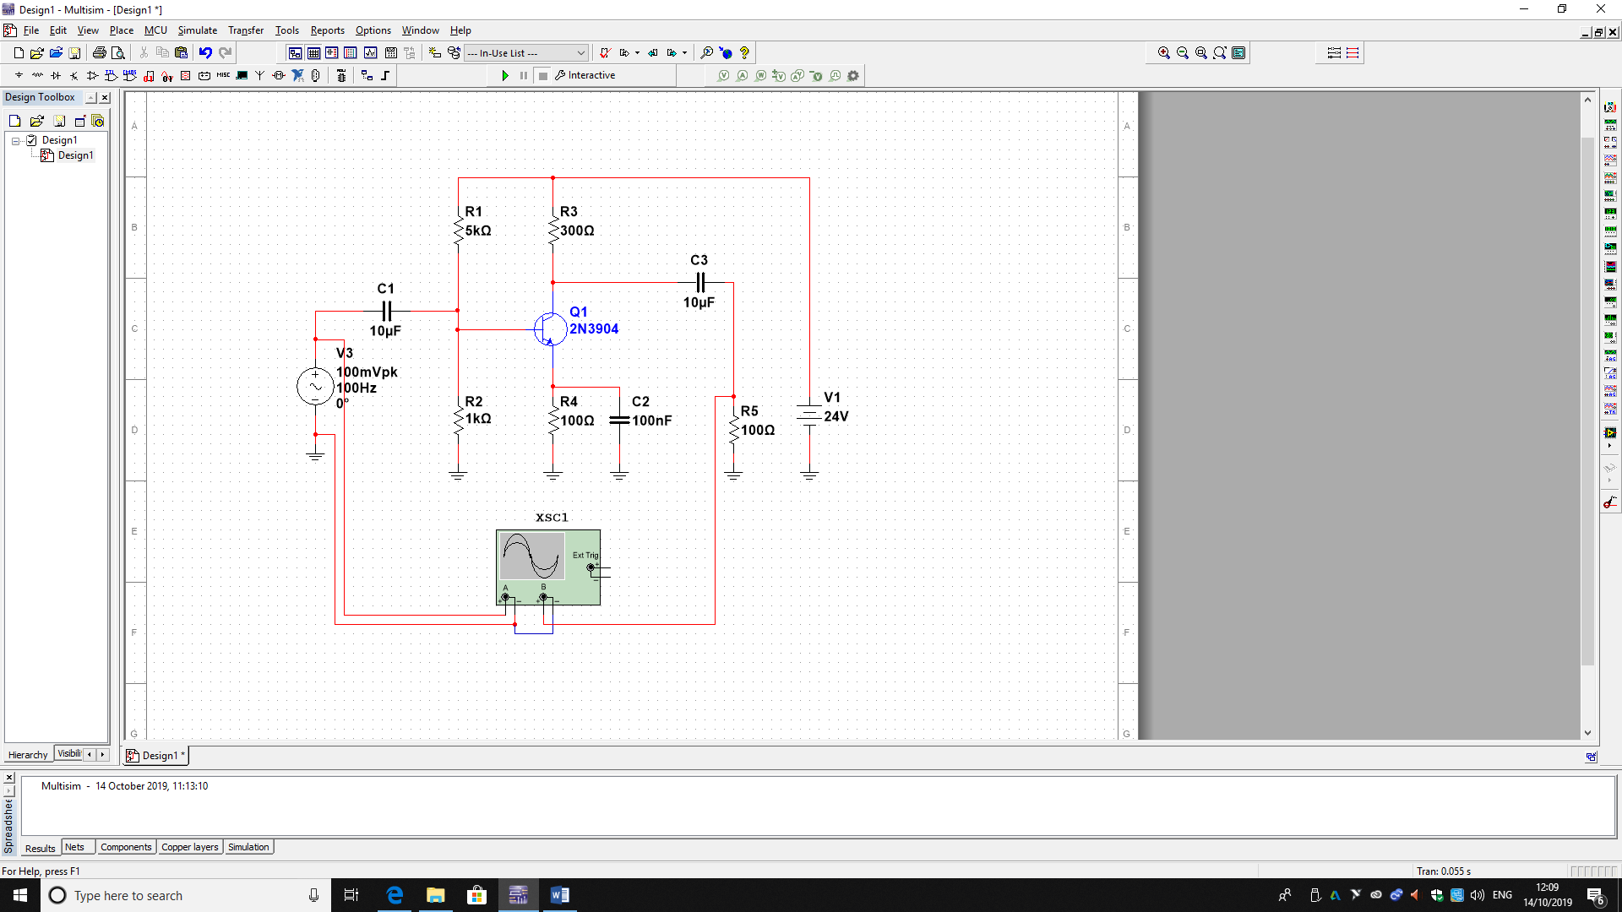Fig1.1

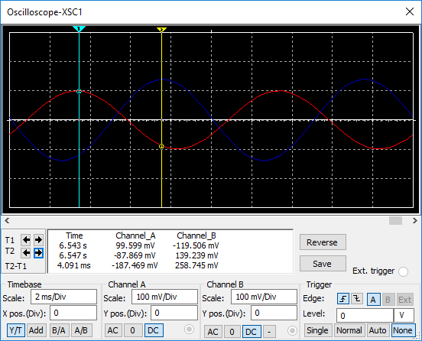fig 1.2

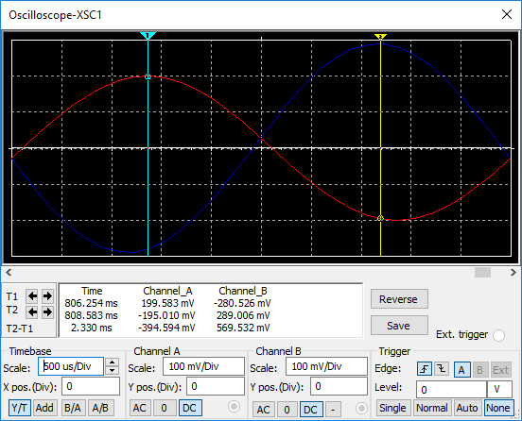fig 1.3

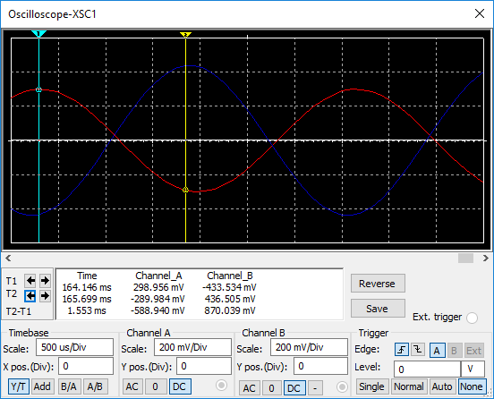fig 1.4

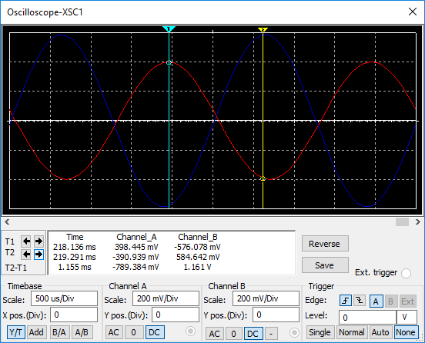fig 1.5

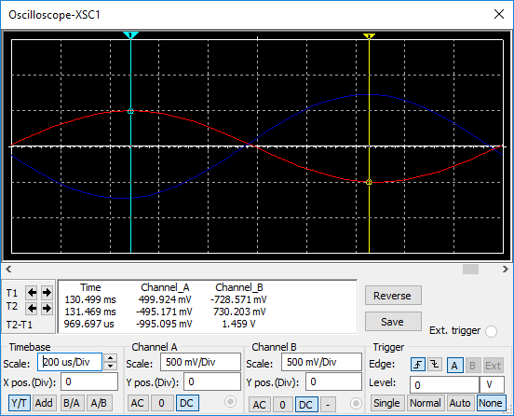fig 1.6

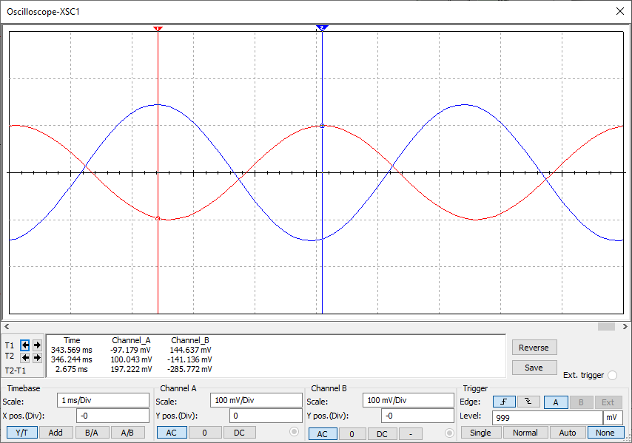 fig 1.7

CLASS B AMPLIFIER

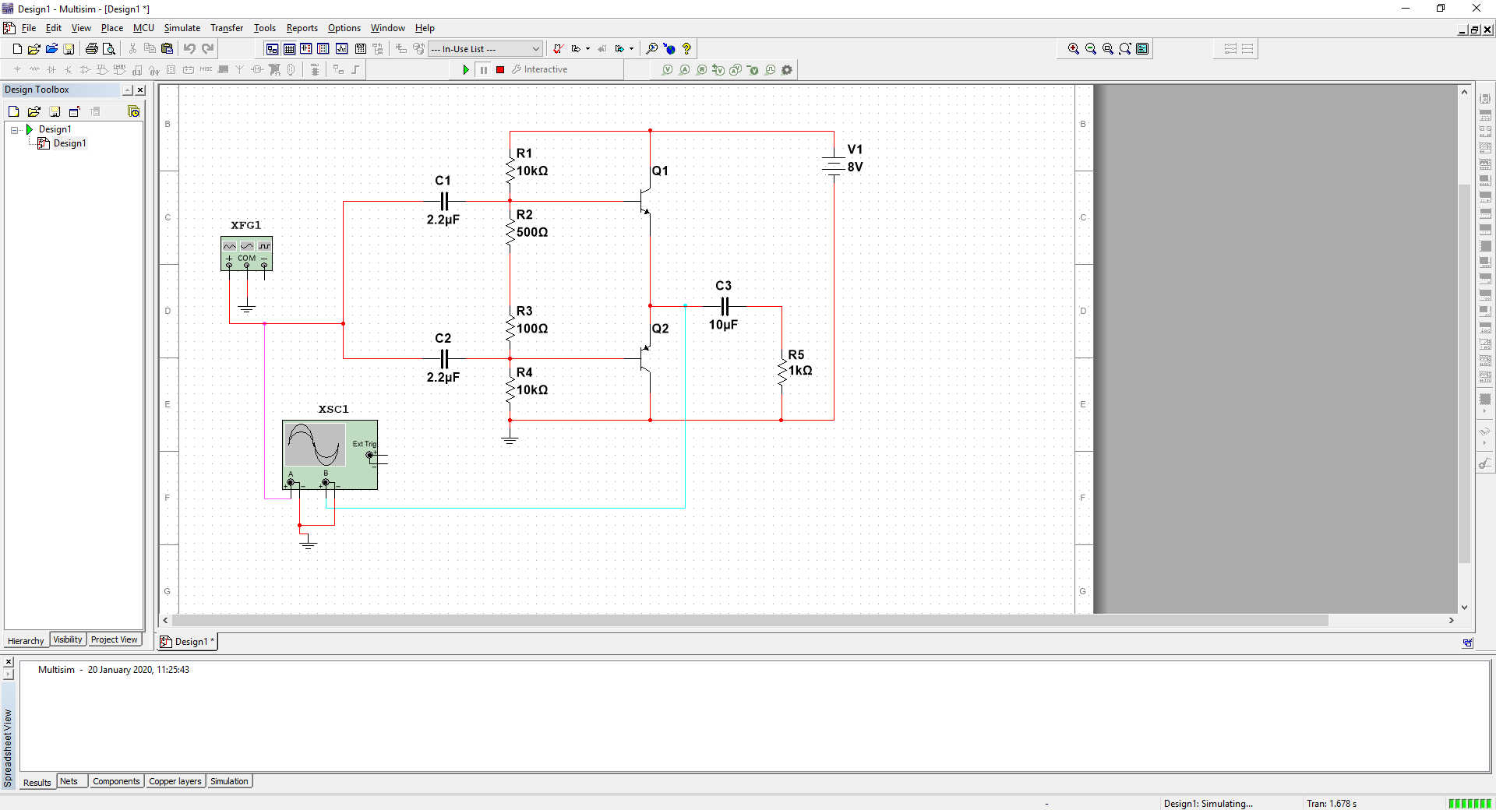fig 1.8

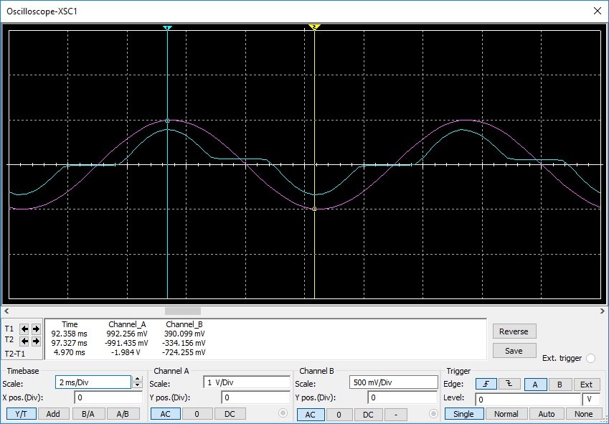fig 1.9

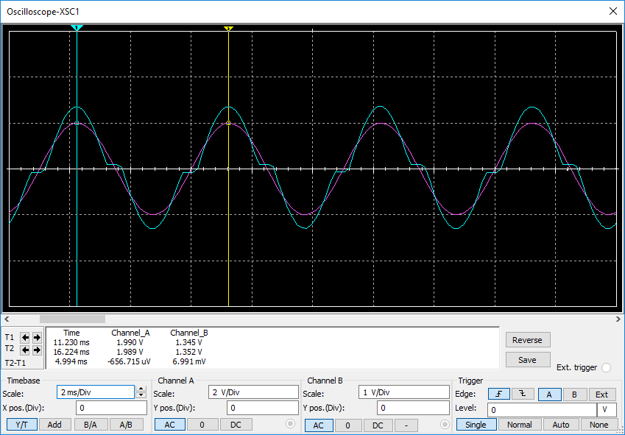fig 1.10

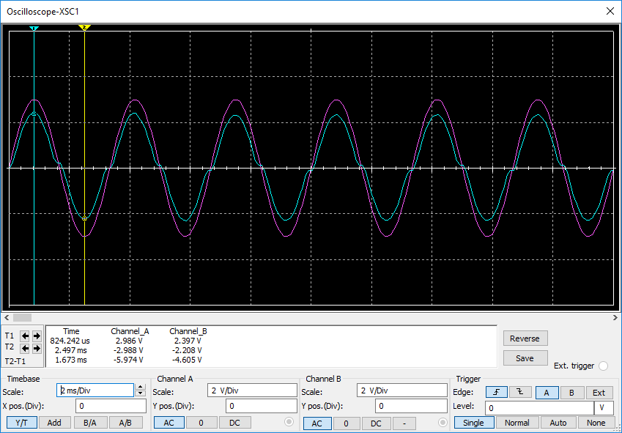fig 1.11

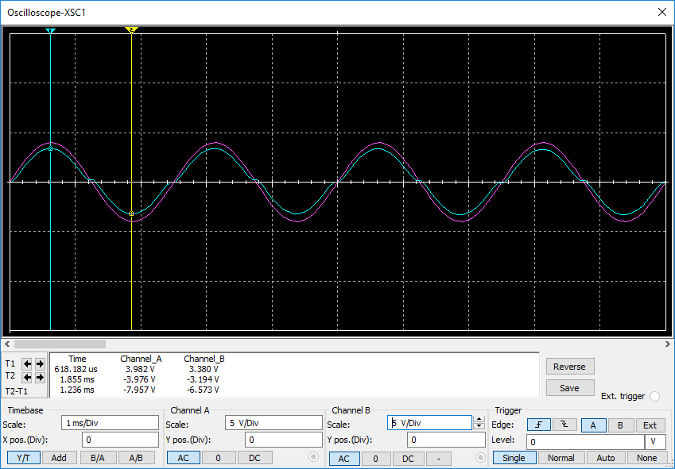fig 1.12

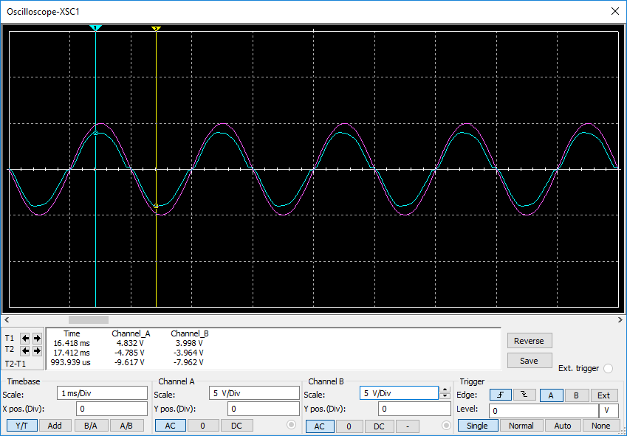fig 1.13

CLASS A AMPLIFIER PRACTICAL

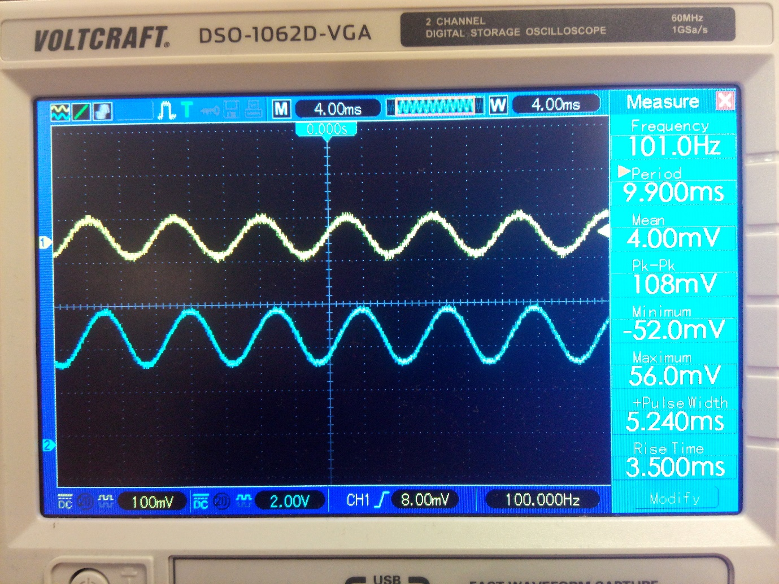

Fig 1.14

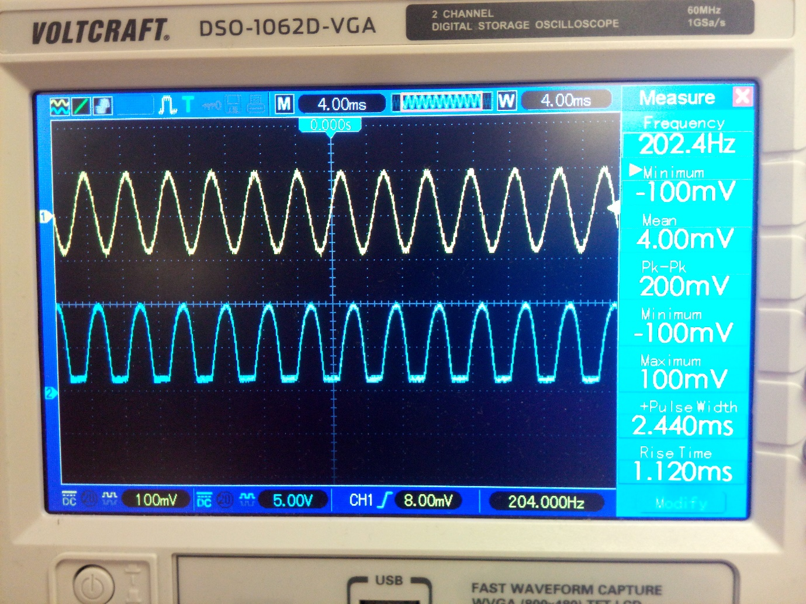

Fig 1.15

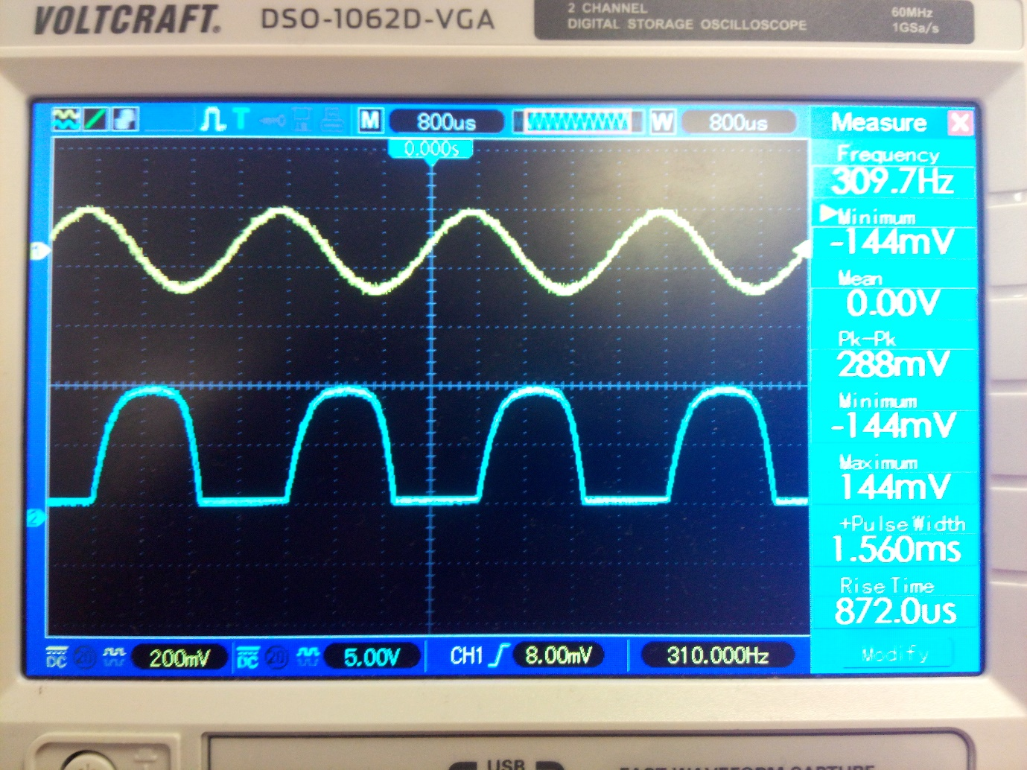

Fig 1.16

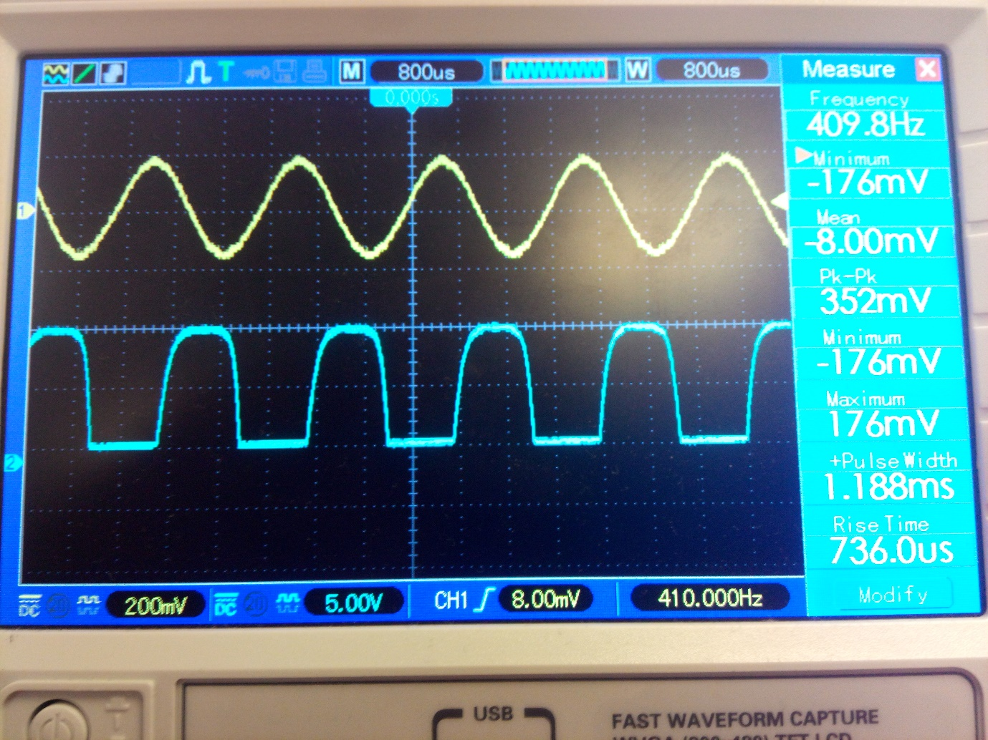

Fig 1.17

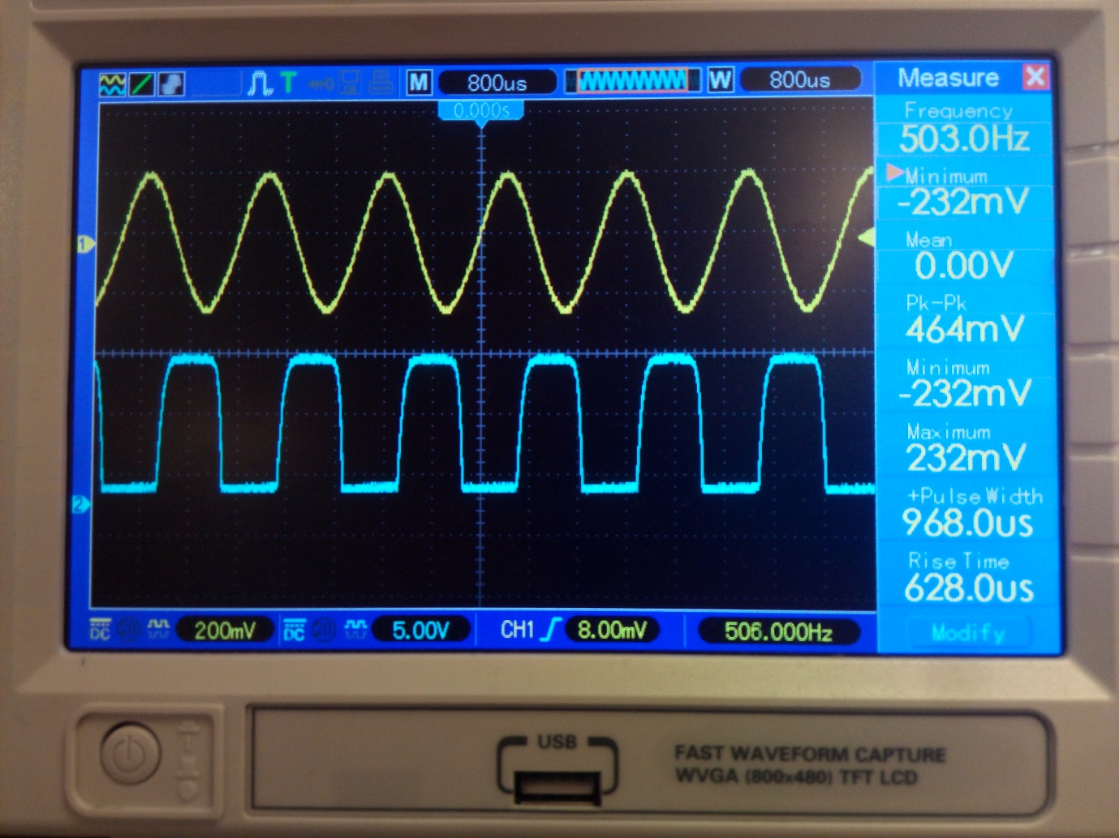

Fig 1.18

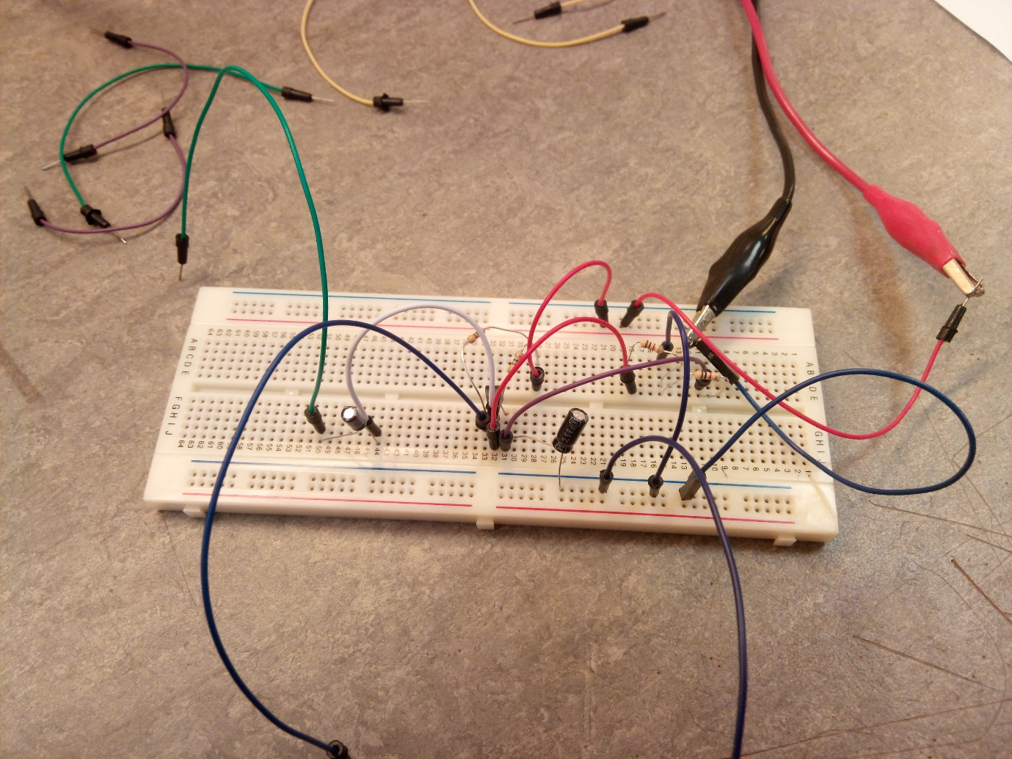

Fig 1.19

## Part B:

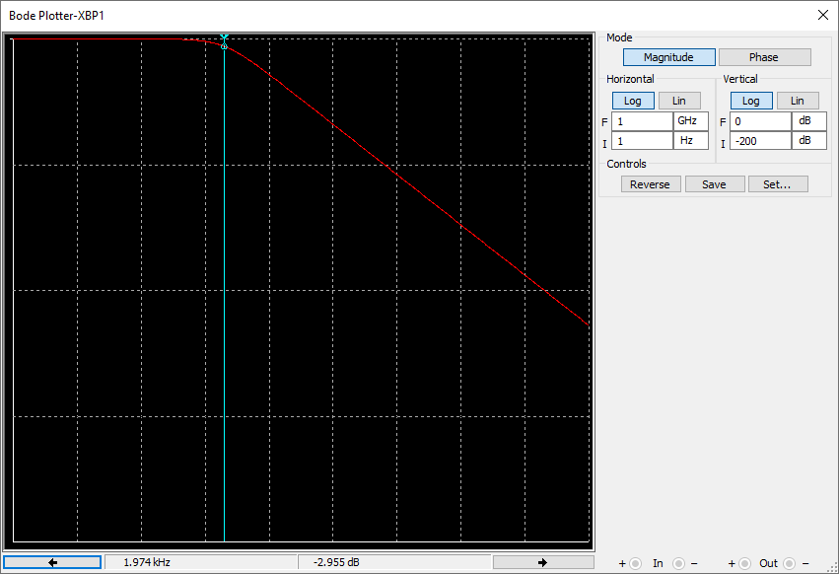

Fig2.1 (Low pass filter bode plot)

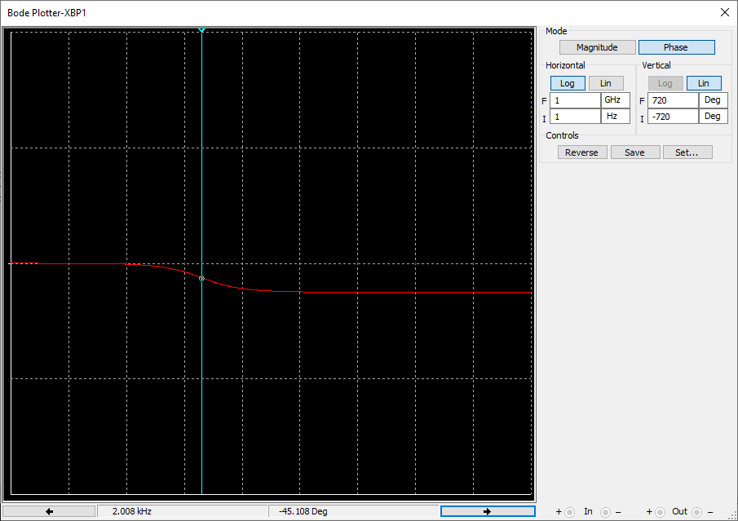Fig 2.2 (Bode phase plot)

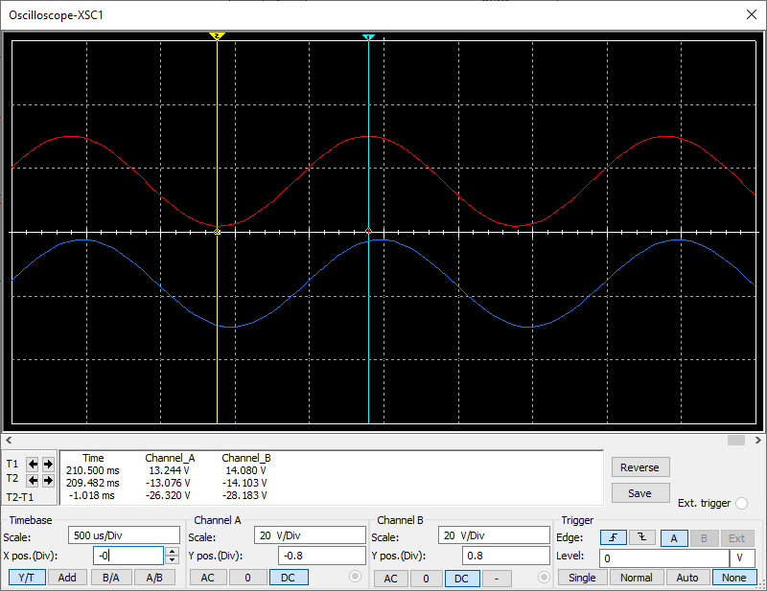Fig 2.3 (low pass oscilloscope at 500Hz)

Input signal: 10Vrms = 14Vpk

Output signal: 9.66Vrms = 13.665Vpk

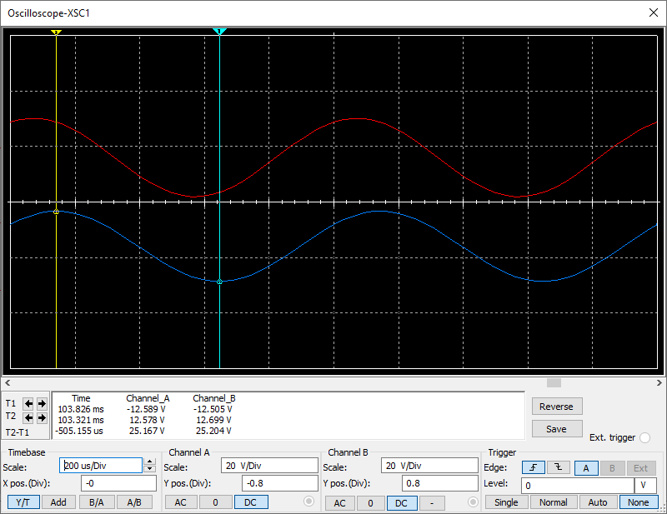Fig 2.4 (low pass at 1KHz)

Output signal: 8.97Vrms = 12.699Vpk

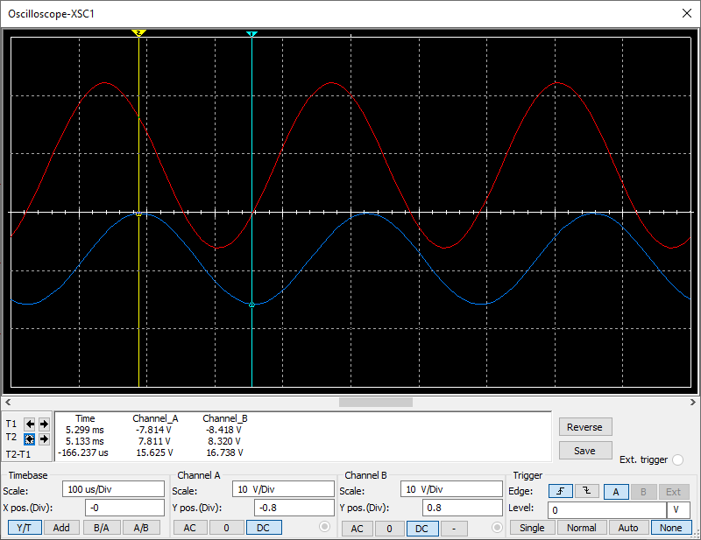Fig 2.5 (low pass at 3KHz)

Output signal: 5.52Vrms = 7.811Vpk

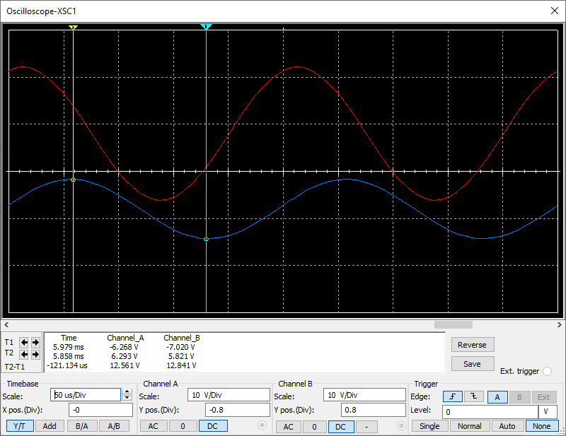Fig 2.6 (low pass at 4KHz)

Output signal: 4.44Vrms = 6.293Vpk

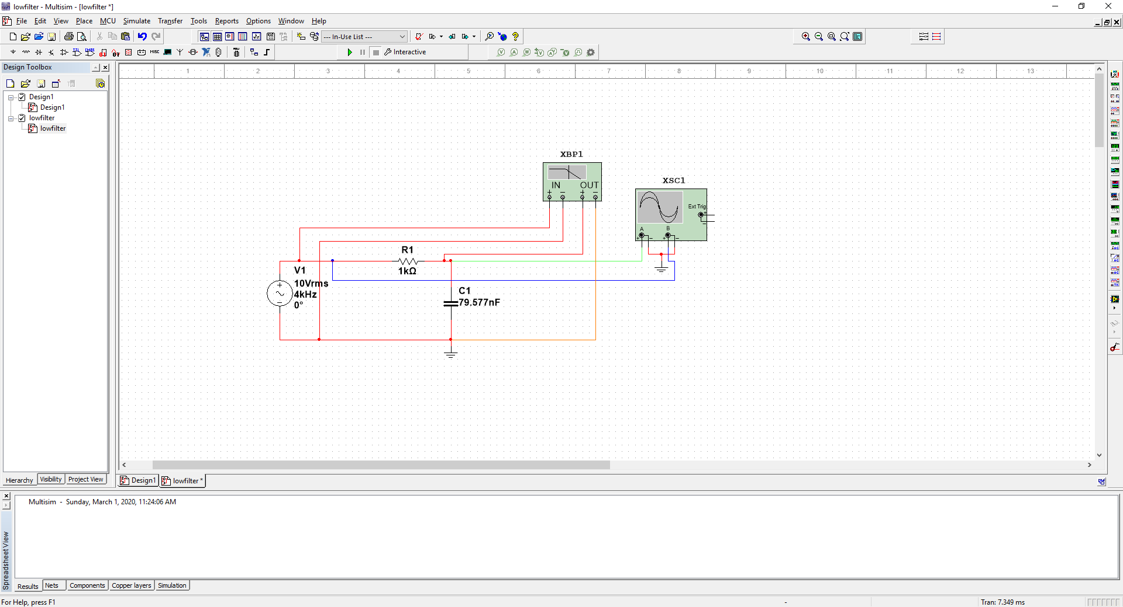

Fig 2.7 (low pass circuit)

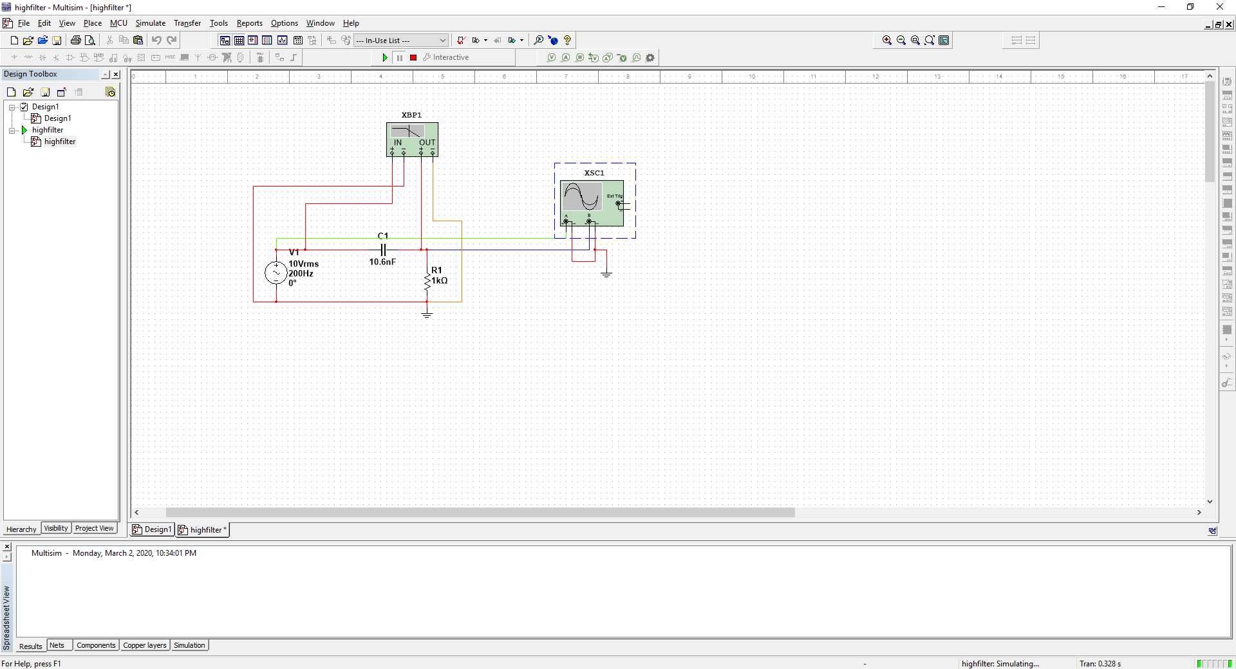Fig 2.8 (high pass circuit)

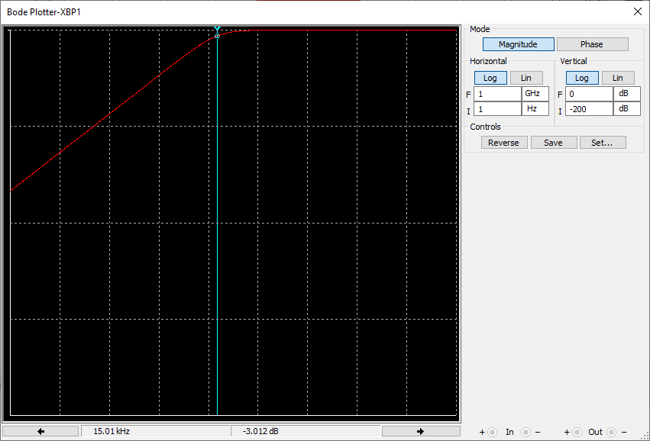Fig 2.9 (high pass filter bode)

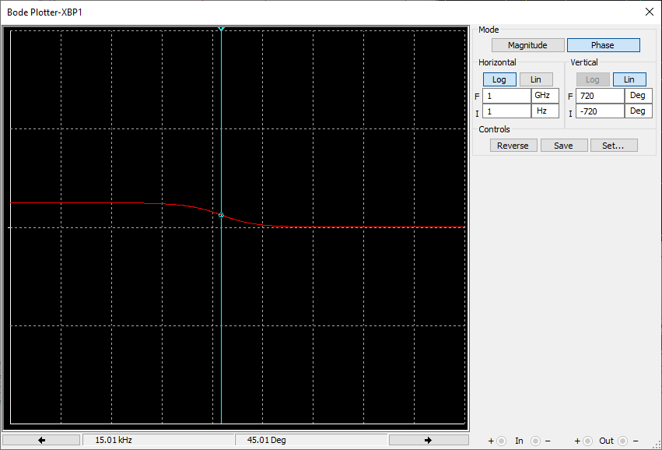

Fig 2.10 (high pass phase plot at 45deg)

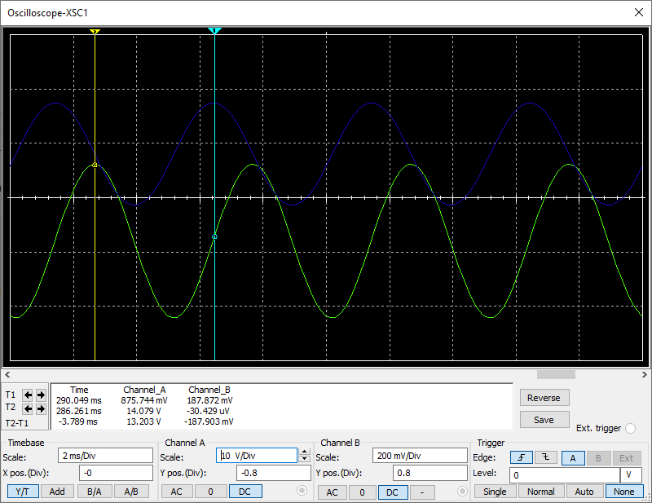

Fig 2.11 (high pass at 200Hz)

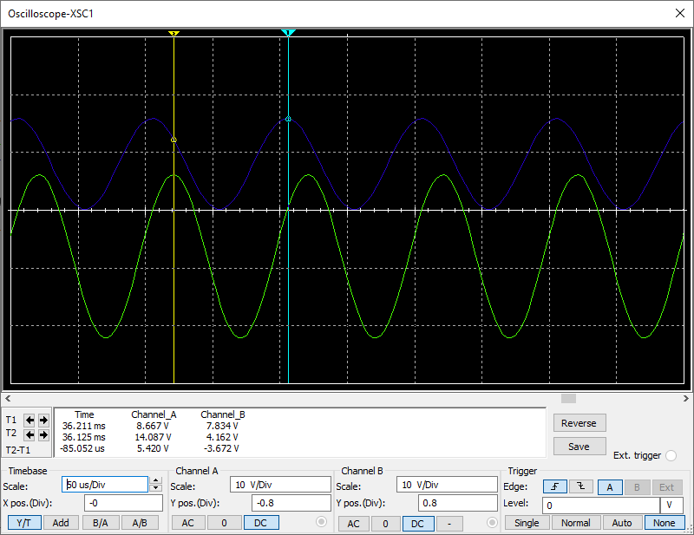

Fig 2.12 (high pass at 10KHz)

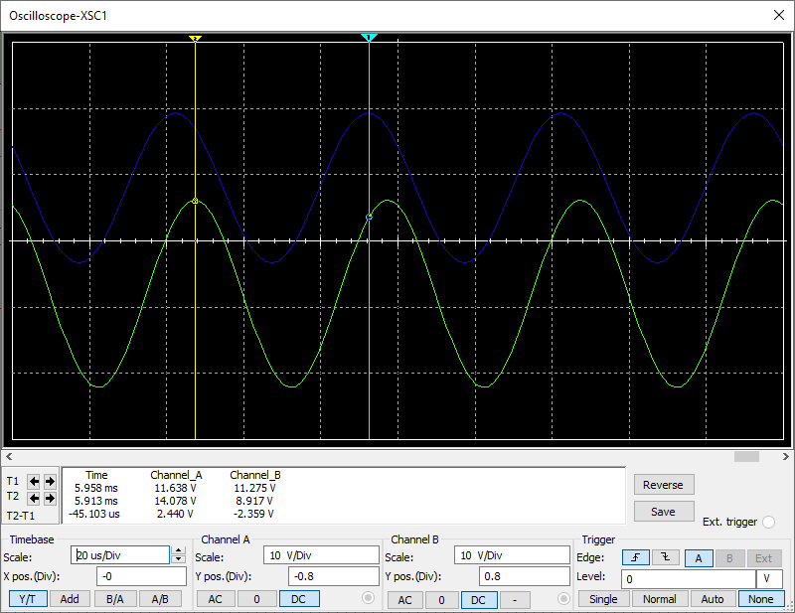

Fig 2.13 (high pass at 20KHz)

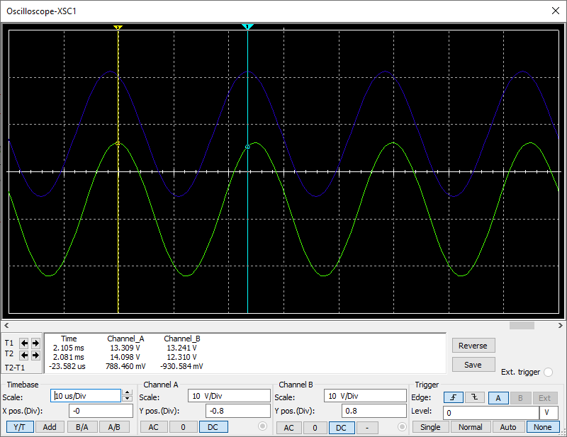

Fig 2.14 (high pass at 40KHz)

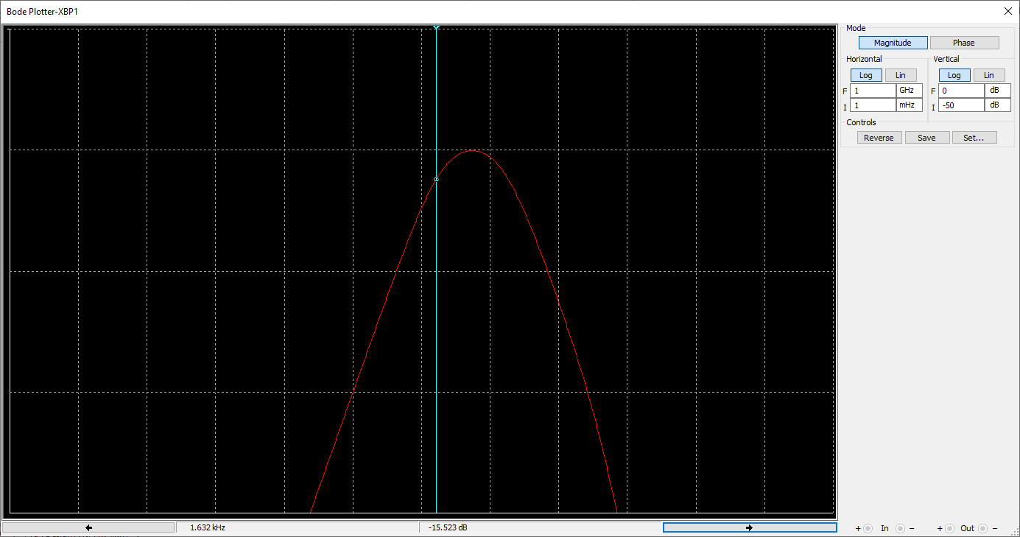Fig 2.15 (-3dB for lower cut off at -3dB)



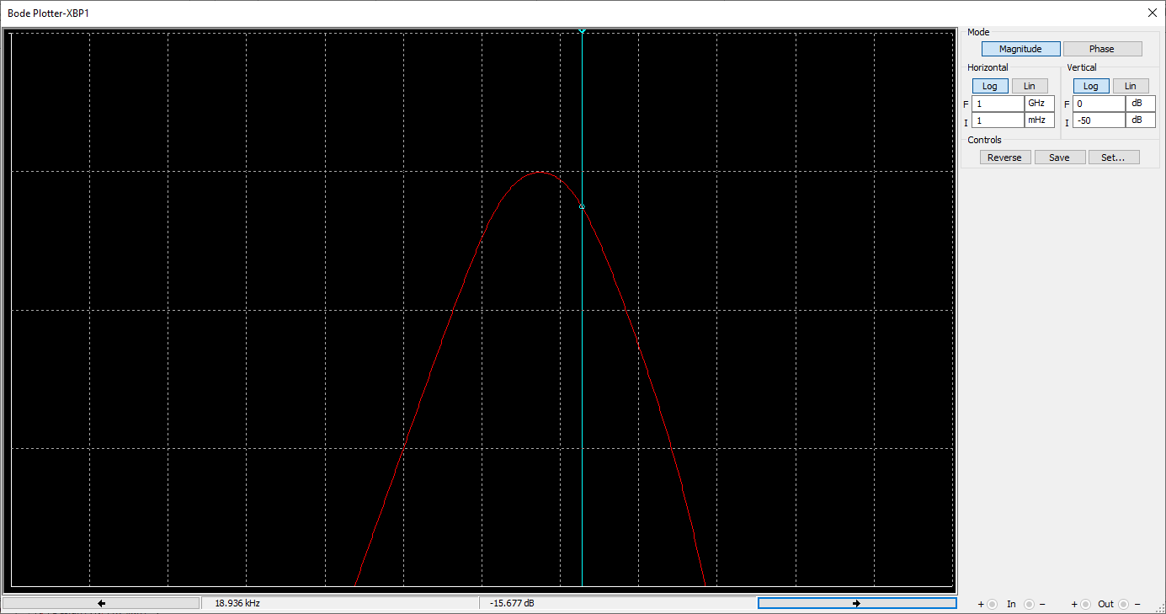Fig 2.16 (-3dB for upper cut off at -3dB)



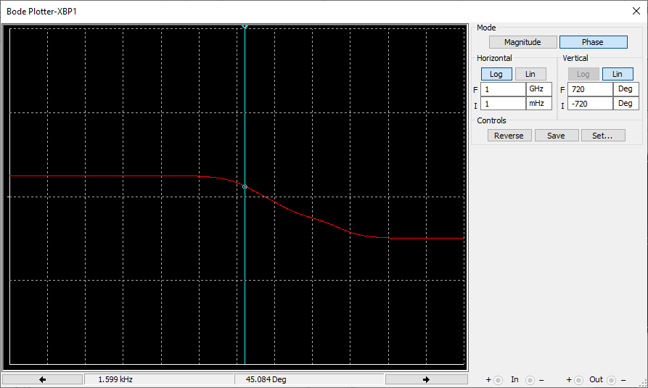Fig 2.17 (upper cutoff at half power)

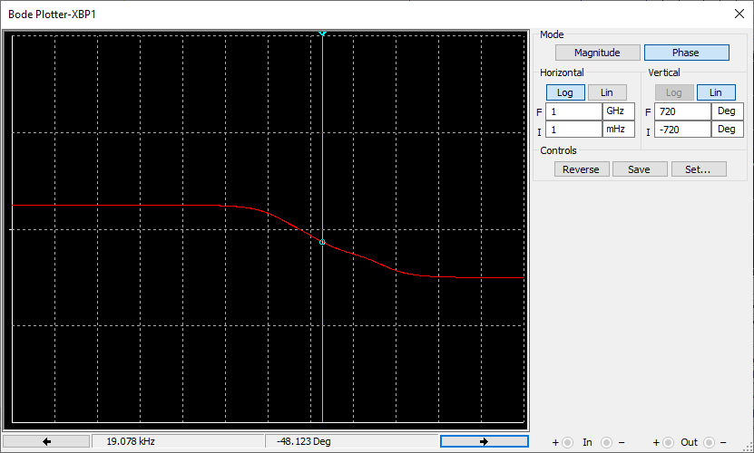Fig 2.18 (lower cutoff at half power)

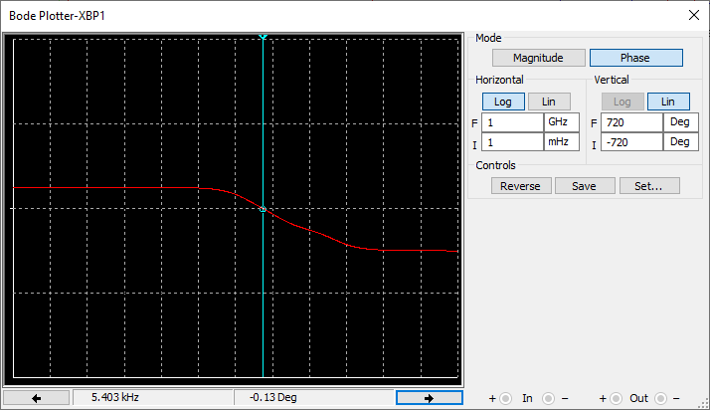

Fig 2.19 (the frequency at which there is no lagging or leading)

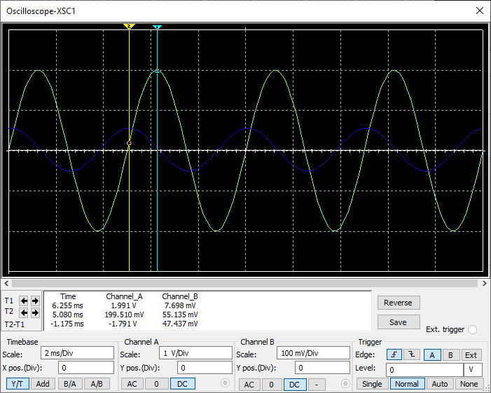Fig 2.20 (200Hz)

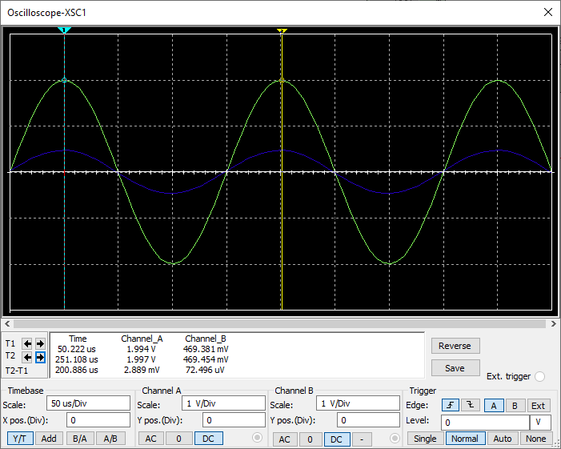Fig 2.21 (5KHz)

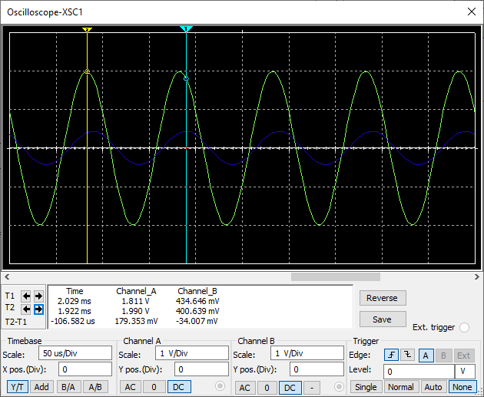Fig 2.22 (10KHz)

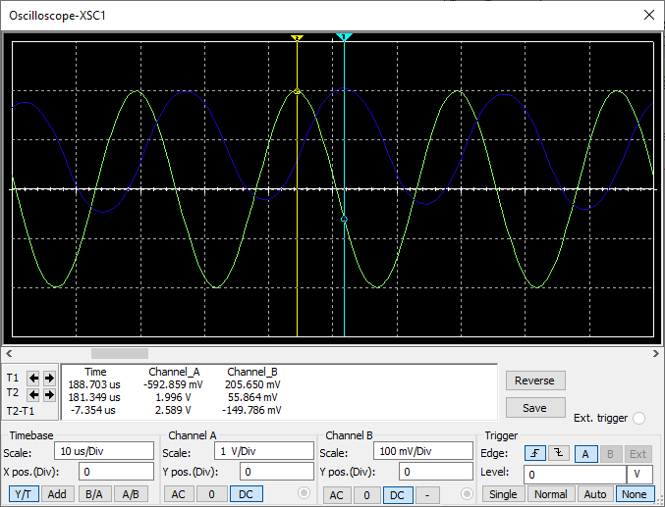Fig 2.23 (40KHz)

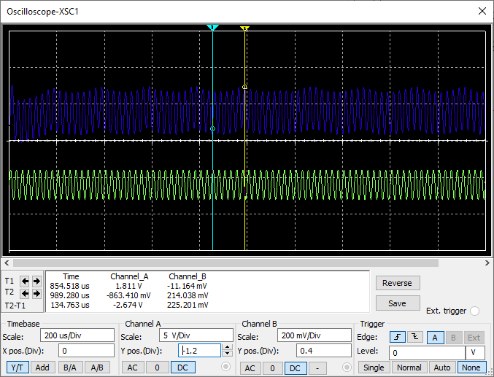Fig 2.24 (waveform at 40KHz)

## Part C:

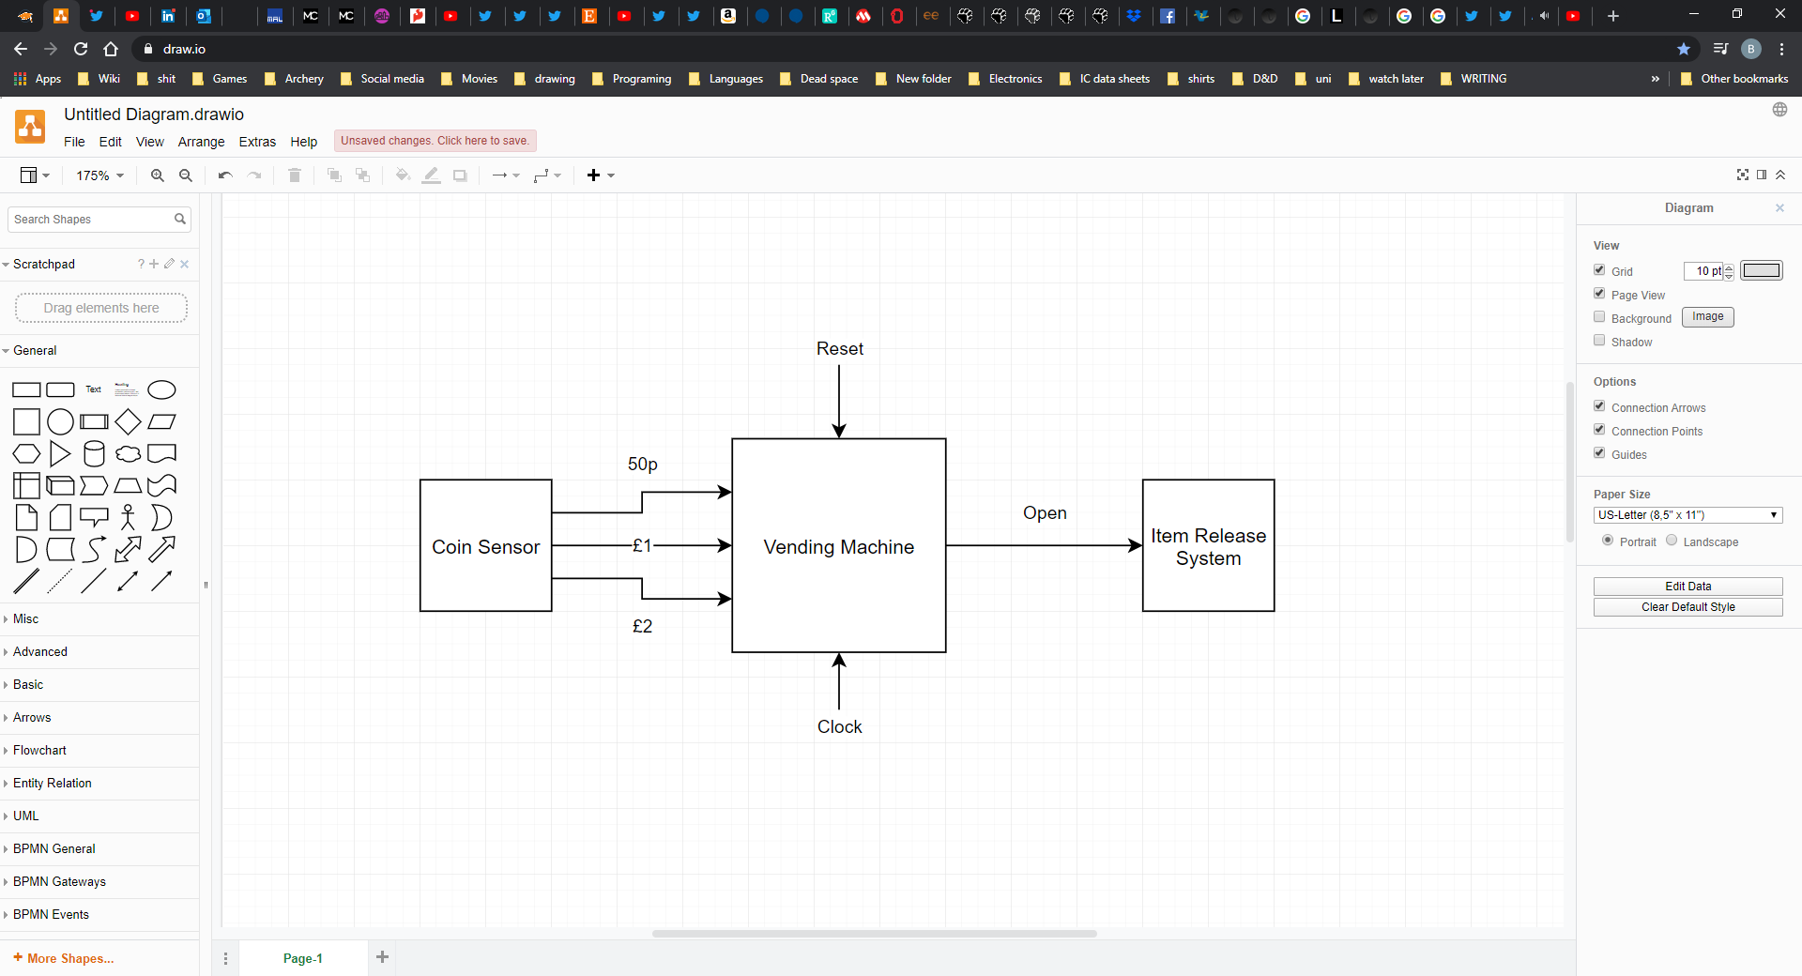

Fig 3.1 (block diagram)

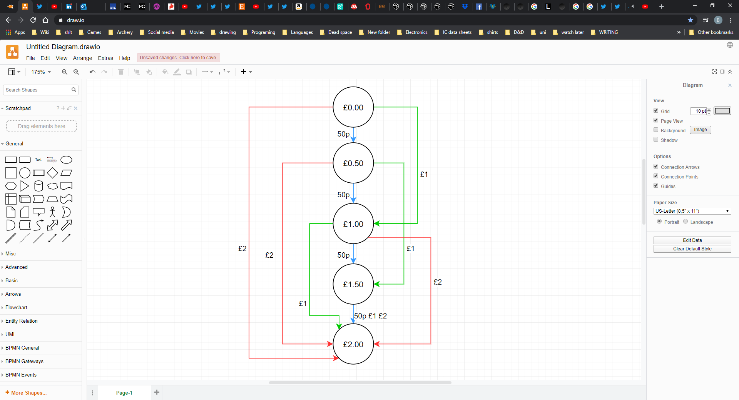

Fig 3.2 (State flow chart)

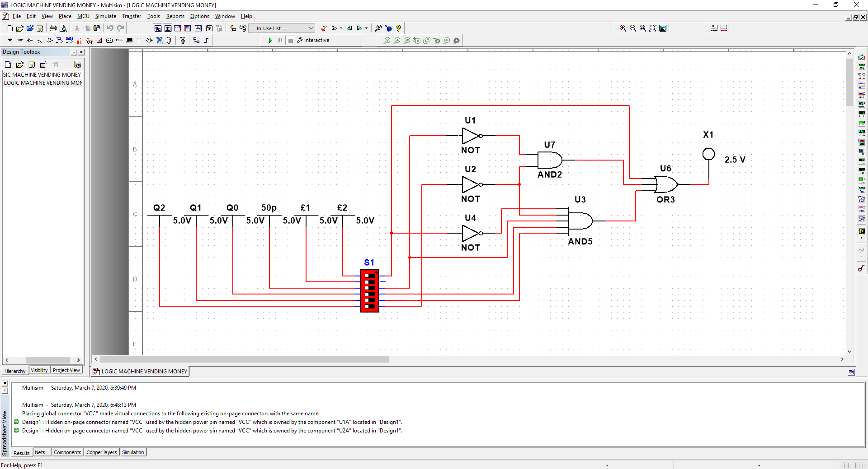

Fig 3.3 (for D2)

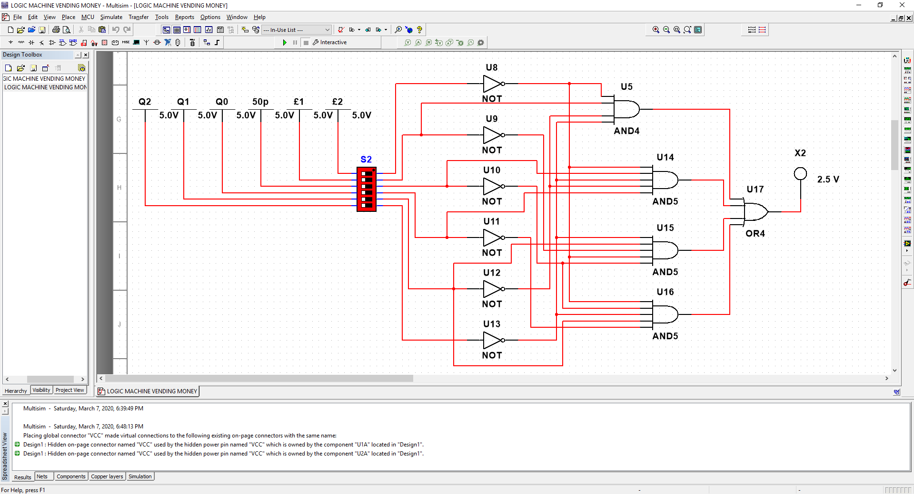

Fig 3.4 (for D1)

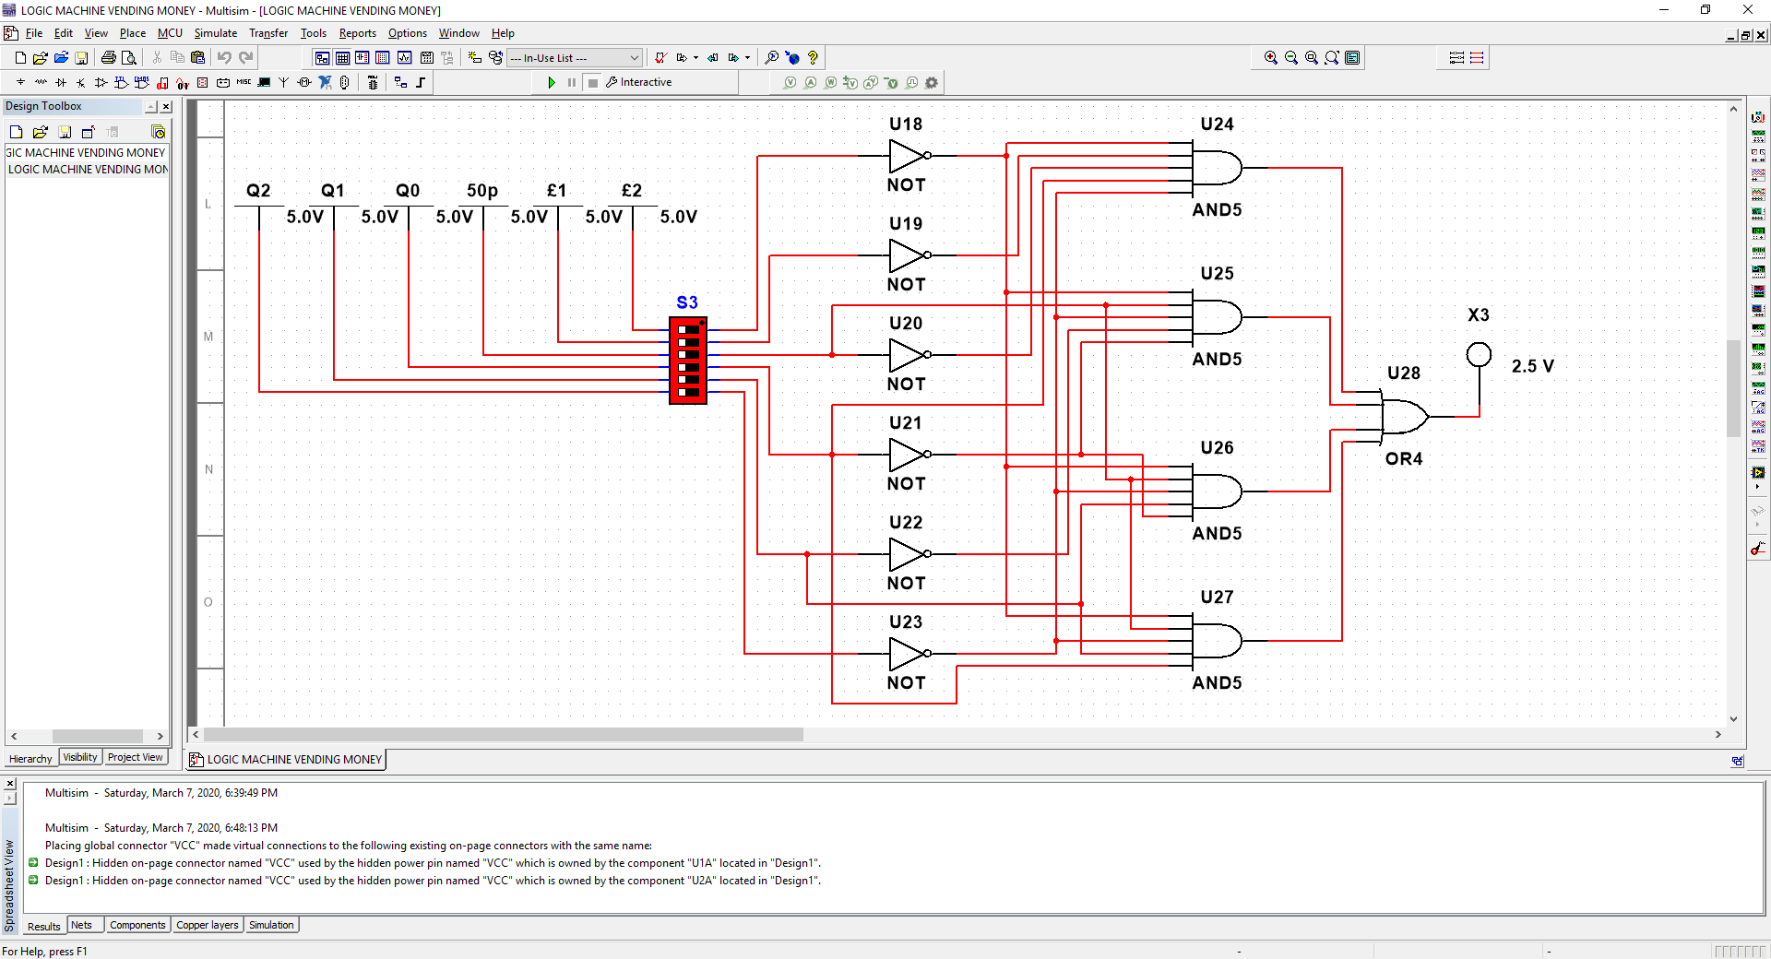

Fig 3.5 (for D0)

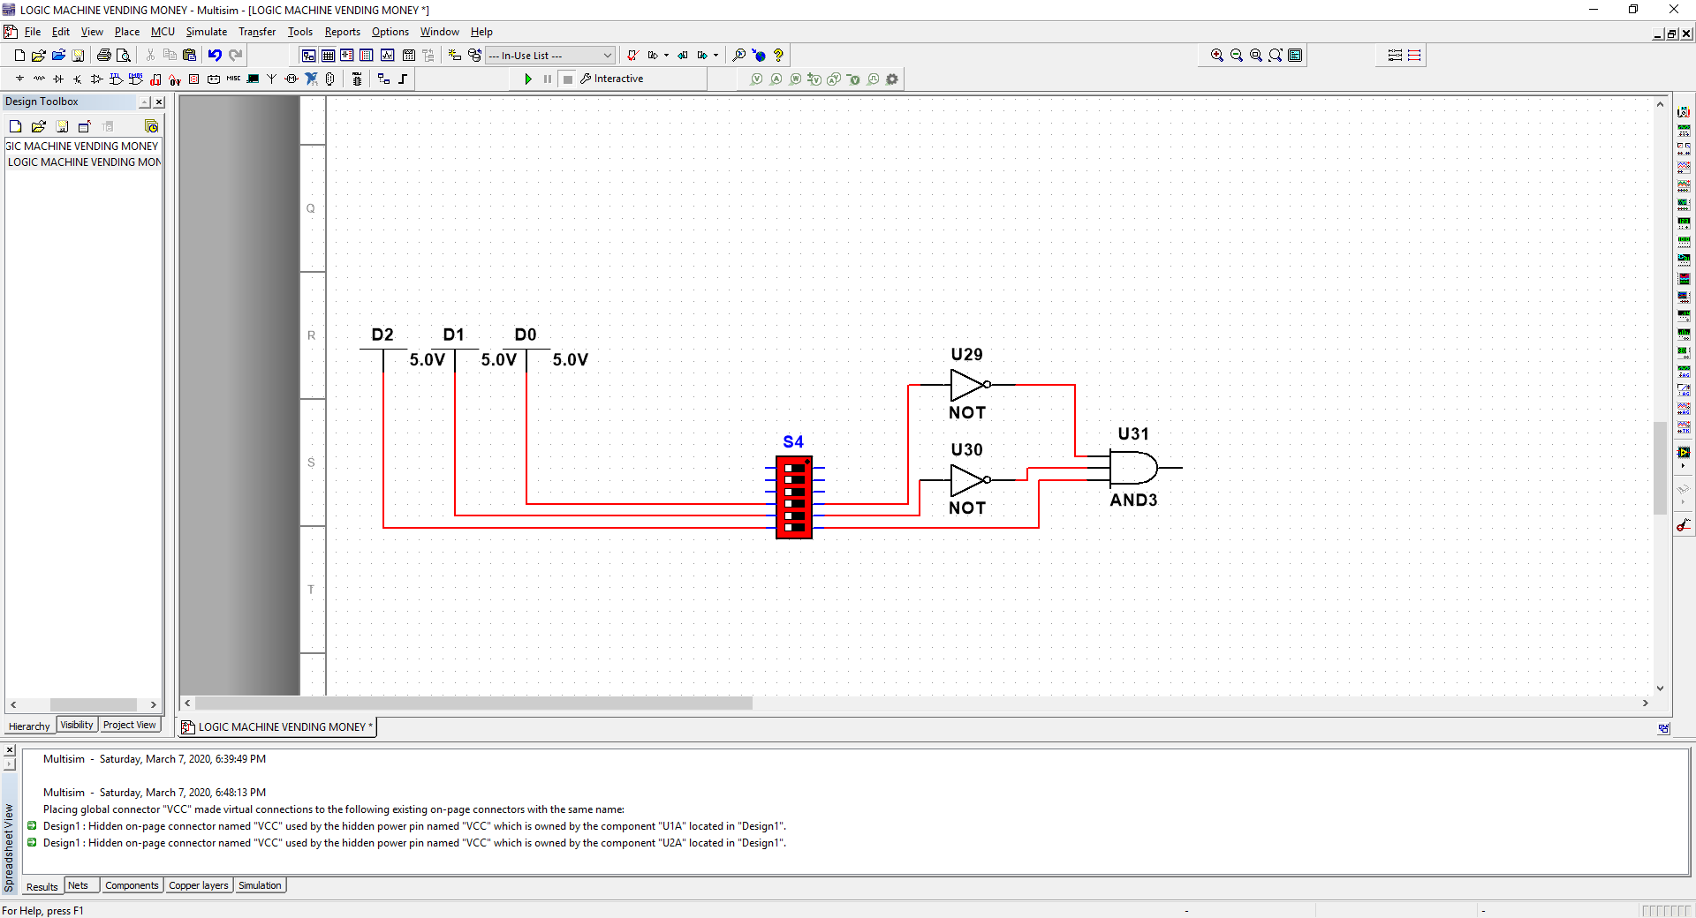

Fig 3.6 (for Logic Open)

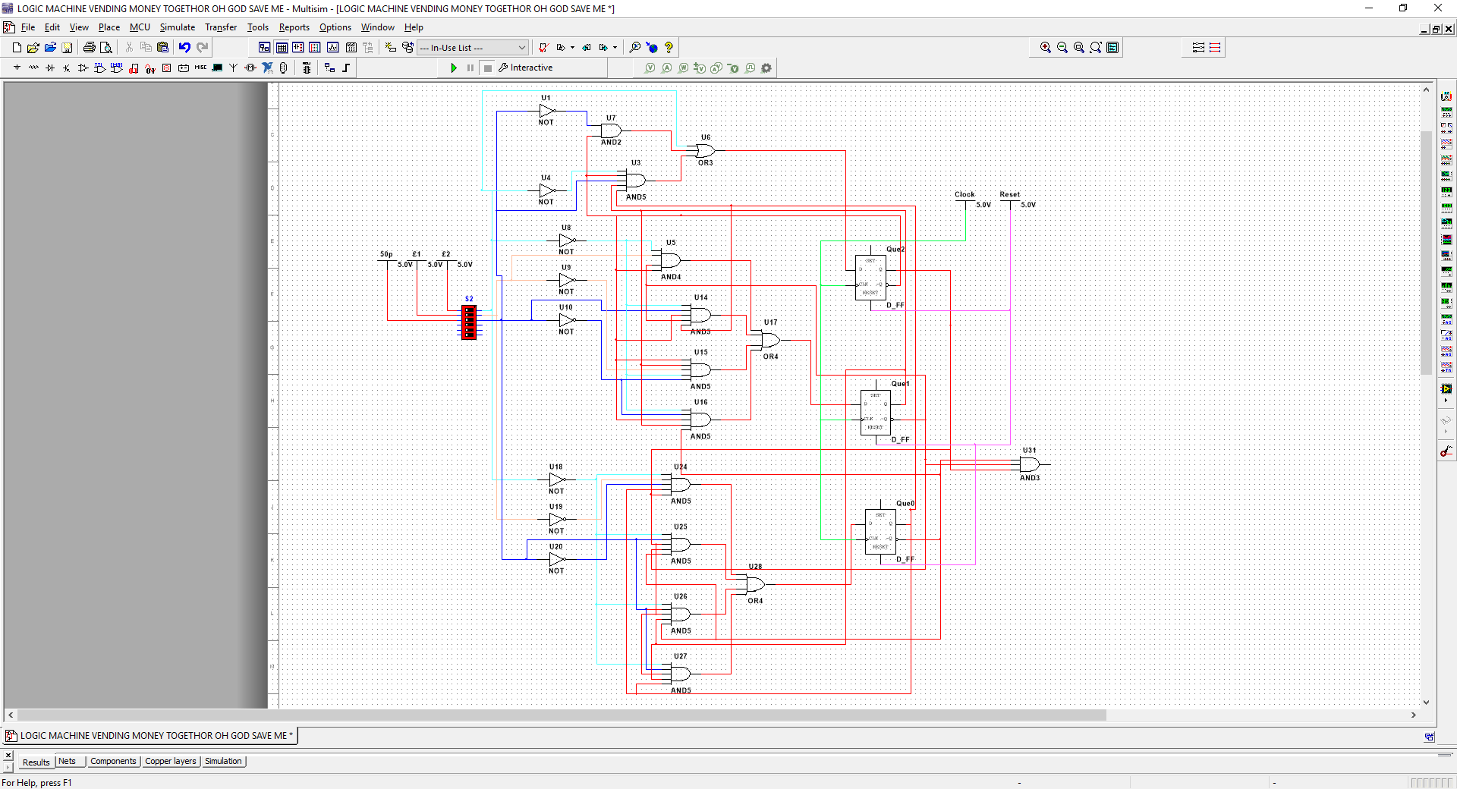

Fig 3.7 (Complete logic circuit design)

# Tables Task A: -

Class A with the resistor going to ground

|  |  |  |
| --- | --- | --- |
| Vin | Freq | Vout |
| 100mV | 100 | 139.239mV |
| 200mV | 200 | 289.006mV |
| 300mV | 300 | 436.505mV |
| 400mV | 400 | 584.642mV |
| 500mV | 500 | 730.203mV |

Table 1.1

Class A without resistor going to ground

|  |  |  |
| --- | --- | --- |
| Vin | Freq | Vout |
| 100mV | 100 | 309.979mV |
| 200mV | 200 | 582.558mV |
| 300mV | 300 | 877.448mV |
| 400mV | 400 | 1.174V |
| 500mV | 500 | 1.466V |

Table 1.2

Class B amplifier

|  |  |  |
| --- | --- | --- |
| Vin | Freq | Vout |
| 1V | 100Hz | 390mV |
| 2V | 200Hz | 1.345V |
| 3V | 300Hz | 2.397V |
| 4V | 400Hz | 3.380V |
| 5V | 500Hz | 3.998V |

Table 1.3

# Tables Part B: -

|  |  |  |  |
| --- | --- | --- | --- |
| Voltage in (Vs) | Frequency (Hz) | Reactance (Xc) | Voltage (V) |
| 10V | 500Hz | 4K | 9.7V |
| 10V | 1KHz | 2K | 8.9V |
| 10V | 3KHz | 666.67 | 5.5V |
| 10V | 4KHz | 500 | 4.47V |

Table 2.1 (low pass calculated)

|  |  |  |  |
| --- | --- | --- | --- |
| Vin | Freq | Vout | Gain |
| 10V | 500Hz | 9.66Vrms | 0.966 |
| 10V | 1KHz | 8.89Vrms | 0.889 |
| 10V | 3KHz | 5.52Vrms | 0.552 |
| 10V | 4KHz | 4.44Vrms | 0.444 |

Table 2.2 (Low pass)

|  |  |  |  |
| --- | --- | --- | --- |
| Voltage in (Vs) | Frequency (Hz) | Reactance (Xc) | Voltage (V) |
| 10V | 200Hz | 75K | 133.32mV |
| 10V | 10KHz | 1.5K | 5.5V |
| 10V | 20KHz | 750 | 8V |
| 10V | 40KHz | 375.3 | 9.36V |

Table 2.3 (high pass calculated)

|  |  |  |  |
| --- | --- | --- | --- |
| Vin | Freq | Vout | Gain |
| 10V | 200Hz | 132.8mVrms | 0.013 |
| 10V | 10KHz | 5.54Vrms | 0.554 |
| 10V | 20KHz | 7.97Vrms | 0.797 |
| 10V | 40KHz | 9.36Vrms | 0.936 |

Table 2.4 (High pass)

# Tables Task C: -

(Encoded states for method 1)





(Karnaugh maps for D0 – D2)

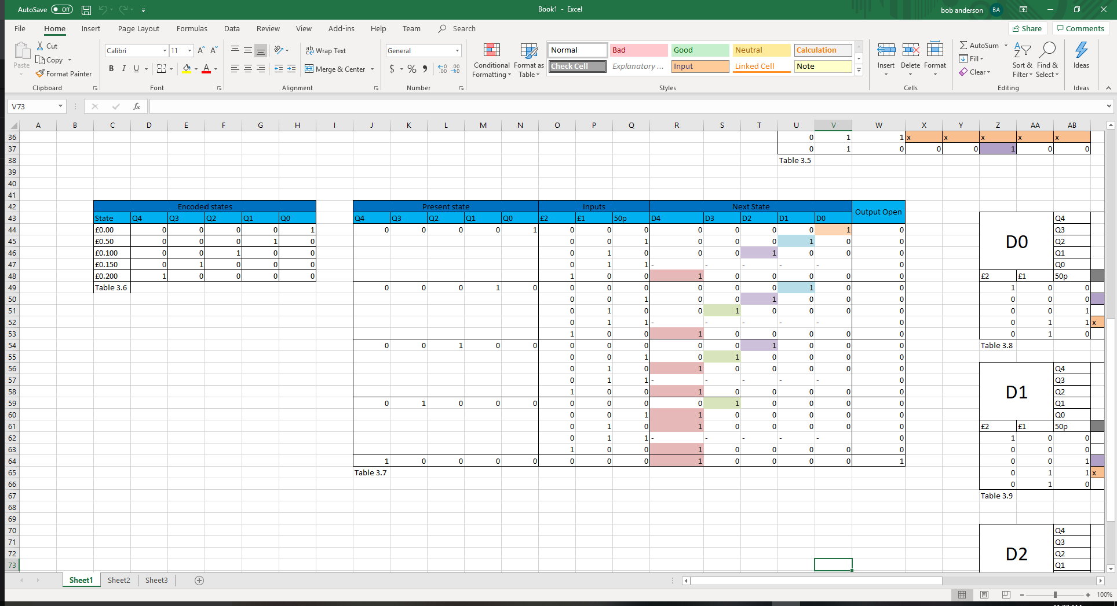(Encoded states for method 2)





(Karnaugh maps from D4 – D0)

# Body: -

# Part A - Amplifiers: -

## Task 1:

After building the class A amplifier in multisim, I had documented and ran multiple tests which had first included the circuit variation where a resistor is connected to ground at the output, I’ll explain why I have done this after the next test with the removed resistor. The circuit diagram can be seen in fig 1.1 and table 1.1 shows the results gathered from this first experiment.

fig 1.1

|  |  |  |
| --- | --- | --- |
| Vin | Freq | Vout |
| 100mV | 100 | 139.239mV |
| 200mV | 200 | 289.006mV |
| 300mV | 300 | 436.505mV |
| 400mV | 400 | 584.642mV |
| 500mV | 500 | 730.203mV |

Table 1.1

As seen from the table above, I had altered and increased the input voltage and the frequency of that voltage by 100mV and 100Hz per interval, using smaller values to test the gain, so the output result wouldn’t saturate from amplifying the first test value.

I had conducted each test up until I had reached the 500mV and 500Hz measurement. The resulting waveforms can be seen in fig’s 1.2-6. These waveforms show that the output of the amplifier is out of phase by around 180 degrees, with little to non-existent noise distortion from the amplified signal. This lack of noise distortion is a product of the design of the circuit, allowing the transistor to be always on with the initial required activation voltage of 0.7V. At no point will the amplifier produce noise from the transistor needing to switch on and off, by exceeding the activation voltage every half cycle.

The gain for this amplifier can be found using the formula…

**(gain = Vout/Vin)**.

So, using this formula and the first result from the first circuit variation, the gain value would be…

**(139.239mV/100mV = 1.39)**

To test this, I can take an input value from my test results, apply the gain to it and compare the results from the calculation to the recorded results. So, using the value of…

**(300mV*1.39 = 417mV)**

…and the recorded value is **436.505mV**, which shows that my calculated values and my simulated results are similar enough.

However, here I can see a discrepancy. So, going back into multisim, I adjusted the frequency value to 200Hz at 100mV and recorded a new result. This result can be seen in fig 1.7, giving the result of 144.637mV at the output. So, using the formula again…

**(144.637mV/100mV = 1.446)**

…and applying the gain to 300mV again…

**(300mV*1.446 = 433.8mV)**

…which is a much more accurate value of the recorded 436.505mV in comparison to the gain of 1.39 at 100Hz.



Input Value

Output Value

So, from this I can conclude that there is a high pass filter affect at the input and the output of the amplifier circuit. The first filter had **(1/2*pi*1x10^3*10x10^-6 = 15Hz)** and the output filter had **(1/2*pi*300*10x10^-6 = 53Hz)** (do more for this bit).

So, now looking at the second circuit arrangement without the bleed resistor going to ground at the output, the output values have appeared to have changed with an increase in voltage. So now the gain has increased to a value of **(309.979mV/100mV = 3.09)** for the 100Hz input and **(1.466V/500mV = 2.9)** at 500Hz. So, when the bleed resistor is removed from the output to make an open circuit, the gain and output voltage increases due to the voltage being drained to ground **[2]**. This is because the load resistor, representing the load of a speaker, would consume some of the power of the output value. This is because the output gain goes directly to ground compared to the load due to it being the path of least resistance. Another use for the bleeder resistor is as a safety component to reduce the risk of the user getting shocked from a still fully charged capacitor. A bleeder resistor would then discharge the cap almost instantly, allowing the device to be safely handled. **[2]**

## Task 2:

Following the class-A amplifier, a class-B amplifier was constructed and tested in multisim to simulate and gather results on the output gain.



Looking at the constructed circuit above, it is shown that two transistors is used to construct the amplifier with a voltage divider segment leading into the base of the transistors. The purpose of this is to increase power efficiency by allowing only one transistor to be turned on at each half wave cycle using reverse bias for Q2 when the input signal is +ve allowing forward bias at the Q1 transistor, and vice versa **[3]**. This means that, a positive value allows current to run through one transistor and not the other while also doing the same vice versa at negative signal values. This arrangement has a power efficiency of around 78% **[3]**.

After conducting tests for this amplifier, I can determine the gain by using…

**(gain = vout/vin)**

**…**again. This would give the values of…

**(390mV/1V = 0.39)** at 100Hzand **(3.998V/5V = 0.7996)** at 500Hz.

Once again, this circuit has a high pass filter at the output with the gain loss from the load resistor component that represents the speaker.

The gain for this amplifier is less than one because a class B amplifier will amplify power over just the voltage. So, this type of amplifier will amplify the current instead of the voltage. **[5]**

In comparison to the class A amplifier, this amplifier shows a point at the voltage levels of between -0.7V and 0.7V, where neither of the transistors are at a voltage level high enough to be switched on and so, the voltage output is 0V for that output. This is called the ‘Dead zone’ or crossover distortion **[3]**. For each 180 degrees of the waveform however, there is a time difference between the crossover distortion. This is due to the different resistance values for the R2 and R3 components, therefore, the cut off frequency is different for +ve and -ve half cycles.

fig 1.9



Input Value

Output Value

Looking at fig 1.9 I can see that there is a phase difference between the input and the output signals. This could be due to the phase shift from the RC filter circuit. This can be counteracted by introducing an RL circuit to shift the phase back in the opposite direction to improve efficiency.

## Task 3:

For the third task, a physical class A circuit had to be constructed and tested on a digital oscilloscope provided to the class by the university lab. This circuit was constructed on a breadboard using 1/4W components and powered using an external power supply.

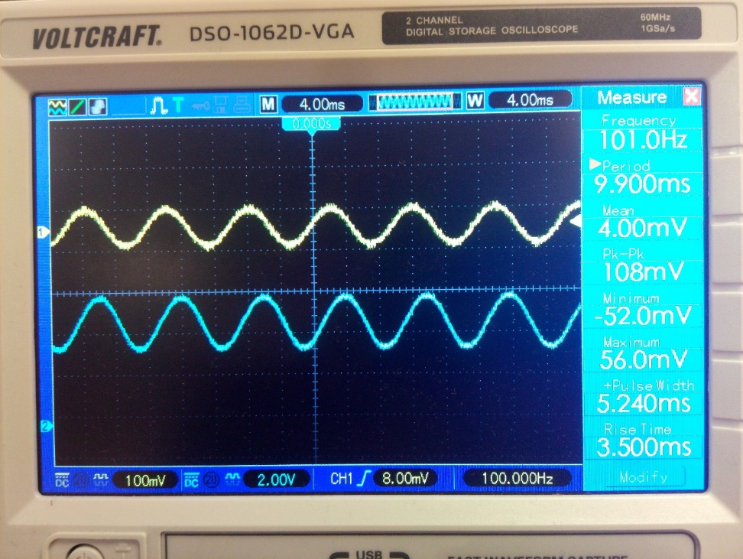

Fig 1.14

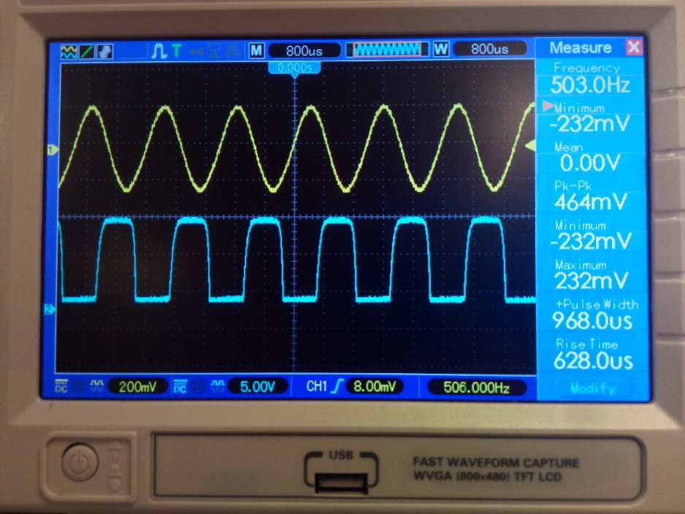

Fig 1.18

Looking at this result for the practical class A amplifier, the gain can be calculated by counting the number of squares and timing that number by the voltage division of that channel. Using this, the formula…

**(Vout/Vin = gain)**

…can be used again. So, in this example, the input signal is 108mV recorded and the output signal is 1.4*2V = 1.4V. using this the gain at 100 Hz is equal to…

**(1.4V/108mV = 12.96)**

and at 500Hz it is shown as…

**((2*5V)/464mV = 21.5)**

At the frequency of 100Hz the gain is 12.96 and at 500Hz the gain is 21.5.

Looking at these results it can be easily seen that the gain has increased with respect to the frequency input value. This effect has also been seen before in Task 1 of Part A with the small change in gain depending on the frequency of the signal. Looking at this, it can be determined by comparing the results of the physical circuit and the simulation circuit that the gain of the active/passive filter circuit has a high gain when the signal frequency is high and a low gain when the frequency is low. This effect is caused by the capacitor reactance creating a voltage divider, automatically adjusting the voltage value across the cap and resistor when the capacitor’s reactance changes **[4]**.

## Conclusion: -

Looking at the results for the class A and B amplifiers, it can be concluded that the class A amp will amplify the signal with a larger gain the higher the signal frequency is. The highest gain achieved using the simulation software and the set testing signal values, is at a value of 1.46 at 500Hz. without the resistor at the output to ground however, the gain rapidly increases to a value of 2.9 at 500Hz. This is because of the voltage trying to find the path to ground using the path of least resistance.

The class B amplifier circuit has a gain of less than one however, consuming the power of the voltage signal but instead amplifying the current of the signal instead. This is the main characteristic of a class B amplifier circuit. Another characteristic that I’ve discovered from this experiment is the crossover distortion that occurs when the voltage reaches a value of 0.7V for one of the transistors. So, a value of 1.4V of data is lost in the crossover distortion due to the voltage requirement of the transistor components.

For the final practical, the class A amplifier circuit was constructed on breadboard and simulated using an oscilloscope and frequency generator. The findings were very similar to the simulation of the class A amp. However, due to the different component choices for this circuit, the gain has increased by a large amount. At 500Hz the gain for this circuit is calculated as 21.5. the saturation shown on the oscillator on the output isn’t due to the characteristics of the amplifier but instead due to a wrong setting on the oscilloscope creating that effect.

# Part B – Filters: -

## Passive Low Pass:

In part B of the assignment, a filter will be constructed in multisim while measuring the output voltage and the half power point using the bode plot. The first filter constructed was the low pass filter with the cut off frequency of 2KHz. To calculate the value of the capacitor the formula…

***(1 /2*pi*Fc*R = C)***

Is used***.*** So, making R = 1KHz, the formula would be…

***(1 /2*pi*2K*1K = 79.577nF)***

Fig 2.1

Fig 2.2

Fig 2.2

Looking at these results, the bode plot for the low pass filter shows the half power point for filters in general is at the -3dB value **[6]**. The cut off frequency at the -3dB is shown as 1.974KHz as calculated above using the formula given provided during lectures.

The roll off from the bode plot shows how dramatic the voltage drop will be past the 2KHz cut-off frequency. As it can be seen, the filter won’t completely cut off the higher frequencies due to it being only a first order filter system. To improve the roll off it is possible to add a layer of filters that will make the roll off steeper and more effective but will also take a larger voltage drop at the output depending on the number of filters that has been connected.

The predicted results for the low pass filter can be calculated by finding…

***(Xc = 1/2*pi*F*C)***

…and then using the voltage divider formula…

***(V = Vs*(Xc/Sqrt(R^2 + Xc^2)))***

…to calculate the final output voltage at that frequency. Calculating the values for all the planned frequency recordings, the values are as follows…

|  |  |  |  |
| --- | --- | --- | --- |
| Voltage in (Vs) | Frequency (Hz) | Reactance (Xc) | Voltage (V) |
| 10V | 500Hz | 4K | 9.7V |
| 10V | 1KHz | 2K | 8.9V |
| 10V | 3KHz | 666.67 | 5.5V |
| 10V | 4KHz | 500 | 4.47V |

Table 2.1

From the oscilloscope the value for the output signal voltage is calculated as…

***(13.665 * 0.7071 = 9.66Vrms)***

…at 500Hz, using the formula…

***(Vpk*0.7071 = Vrms)***

So, seeing this result it can observe that the voltage has dropped across the filter by a gain of…

***(Vout/Vin = gain)***

***…***which can be calculated as…

***(10Vrms/9.66Vrms = 0.966)***

The table of the results are as follows…

|  |  |  |  |
| --- | --- | --- | --- |
| Vin | Freq | Vout | Gain |
| 10V | 500Hz | 9.66Vrms | 0.966 |
| 10V | 1KHz | 8.89Vrms | 0.889 |
| 10V | 3KHz | 5.52Vrms | 0.552 |
| 10V | 4KHz | 4.44Vrms | 0.444 |

Table 2.2

Seeing from these results, it can be seen that the calculated and the recorded results are accurate when compared to each other. The voltage drop gain will also fall the higher the frequency gets to the cut-off frequency. The large voltage drop will also happen when the frequency exceeds the cut-off point. So, the filter won’t be able to cut off the higher frequencies effectively.

The figures 2.3 – 2.6 and 2.2 shows that the increase of frequency also influences the phase shift of the output signal. Making the signal lag the current by a phase angle determined by the frequency of the input signal. So, the higher the input frequency is, the closer the signal is to being 45 degrees lagging out of phase.

## Passive High pass:

The cut of frequency for the High pass filter is 15KHz. So, to calculate the capacitor value the formula…

***(1/2*pi*Fc*R = C)***

…will be used. So, using assuming the resistor value is 1K, then the capacitor value should be…

***(1/2*pi*15K*1K = 10.6nf)***

Fig 2.9

fig 2.10

fig 2.11

Looking at these results, the half power point at -3dB and the phase shift at 45 degrees is at 15KHz as expected. The bode plot shows that the roll-off is low when the frequency is low but will start to rise when the frequency increases, allowing the higher frequencies to pass. This slop requires the circuit to become an nth order system filter in order to become reactive and efficient.

The predicted results can be calculated by finding…

***(Xc = 1/2*pi*F*C)***

…and then using the voltage divider formula…

***(V = Vs*(R/Sqrt(R^2 + Xc^2)))***

…to calculate the final output voltage at that frequency. Calculating the values for all the planned frequency recordings, the values are as follows…

|  |  |  |  |
| --- | --- | --- | --- |
| Voltage in (Vs) | Frequency (Hz) | Reactance (Xc) | Voltage (V) |
| 10V | 200Hz | 75K | 133.32mV |
| 10V | 10KHz | 1.5K | 5.5V |
| 10V | 20KHz | 750 | 8V |
| 10V | 40KHz | 375.3 | 9.36V |

Table 2.3

The results recorded from the oscilloscope are measured in Vpk, which will then need to be converted and calculated to Vrms using the…

***(Vrms = 0.7071*Vpk)***

…formula. The results for these readings can be seen below.

|  |  |  |  |
| --- | --- | --- | --- |
| Vin | Freq | Vout | Gain |
| 10V | 200Hz | 132.8mVrms | 0.013 |
| 10V | 10KHz | 5.54Vrms | 0.554 |
| 10V | 20KHz | 7.97Vrms | 0.797 |
| 10V | 40KHz | 9.36Vrms | 0.936 |

Table 2.4

Comparing these two tables, it is clear that the recorded and calculated results are near identical to each other. Because of this, they both show and prove that the voltage increases when the frequency of the input signal increases. Allowing higher frequencies to pass while also blocking lower frequency signals from passing the filter.

Figure 2.11 – 2.14 and 2.10 shows that the output signal starts being 45 degrees out of phase, the voltage output leading the current. The phase shift difference would then start to reduce as the frequency would increase, being able to be as close as possible to 0 degrees as possible at 1GHz.

## Active Band pass:

This filter circuit consists of a low pass and a high pass filter in arrangement with an operational amplifier. These components are combined to create a band pass active filter circuit. The high pass will have a cut off frequency of 15KHz and the low pass will have a cut off of 2KHz similarly to the two examples above. The op-amp meanwhile, will have a gain of 2 to amplify the voltage signal to make up for the voltage loss across the passive components.



Fig 2.16 Fig 2.18



Fig 2.15 Fig 2.17

Looking at these bode plot results, the -3dB point for each side, which is at a value of -15.6dB. The reasoning for this drop-in decibel could be explained by the point at which the roll-off of both filters cross over to create the band pass effect. This has also produced an effect where the -3db point has slightly different values compared to the calculated frequency high and low cut-off values. The lower -3db value is at 1.6KHz and the upper -3db value is at 18.9KHz. This shows that the bandwidth is wider than what was previously predicted, coming to a value of…

***(BW = fH – fL*** 🡺 ***18.9 – 1.6 = 17.3KHz)***

Compared to the predicted value of…

***(BW = fH – fL 🡺 15KHz – 2KHz = 13KHz)***

  
Fig 2.19

The resonant frequency for this band pass can be calculated by using the formula…

***(Fr = sqrt (FLow*FHigh))***.

So, using this formula the resonant frequency would be at…

***(sqrt(2K*15K) = 5.477KHz)***

This shows that the signal will lead by 90 deg at lower frequencies and cross over to being in phase with the input signal at 5.4KHz. Any higher than that however and the signal will be lagging as far as up to 180 deg depending on if the frequency exceeds hundreds of megahertz. Due to this not being a practical frequency being so high, the output voltage would be too miniscule to even be considered viable. Practically however, the frequency equal to the value of ‘fH’ can produce a viable output with a lagging voltage of -48.1 degrees as shown in fig 2.18.

The gain of the operational amplifier can be calculated using the non-inverting formula…

***(1+(R2/R1) = gain) 🡺 (1+ (1K/1K) = 2)***

This shows that the output of the high pass filter at the beginning of the circuit will be amplified by a gain of 2. However, the output of that amplifier will then be affected by the voltage drop of the low pass filter. The non-inverting amplifier has no effect on the phase of the output signal and has a low possible gain so, it is suitable for an application as a signal buffer amp. This type of application is used for when an oscillator device would become unstable when, a speaker for example, would draw more current than the oscillator could handle. Having an impact on the quality and stability of the oscillator circuit **[5]**. With a buffer however, this effect can be nullified due to the power being supplied to the powered operational amplifier component.

## Conclusion: -

In conclusion, after observing the results of all these tests, it can be shown that the frequency not only influences the voltage loss (gain below 1) at the output but also the phase shift of the signal at the output. Because these first two filters are constructed with just passive components, the circuit would consume some of the power being put into the filter circuit. This can then be combated later in the active band pass filter circuit which utilizes the use of a non-inverting amplifier. This amplifier will offset the power being consumed by the passive components by supplying a secondary supply voltage through the op amp. A gain of 2 will be applied to the input signal through the amplifier. Doubling the voltage signal, so the signal amplitude doesn’t become so small that it becomes negligible.

# Part C – State Machines: -

This task required that a logic circuit is to be designed to dispense an item when the user enters the correct amount of money into the vending machine. First to do this, a flow chart is created to display how the system will move from one stage to the next, depending on the amount of money of the following coin that will be inserted into the machine. This can be seen below…

Fig 2.2

The boolean expression for the logic system would then also need to be calculated using karnaugh maps. Before doing this however, a table is created showing the current stage and the possible inputs that will lead onto the next logical stage. Using this, the Karnaugh maps for D2, D1 and D0 can be shown in table 3.3 – 3.5.

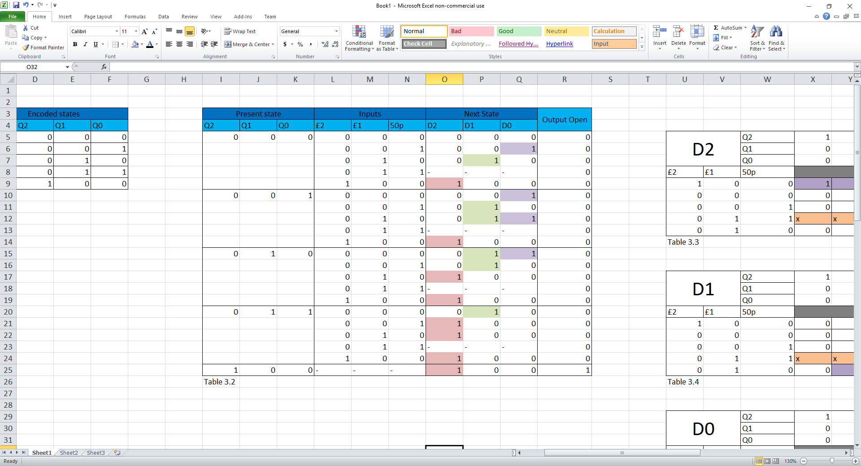

Table 3.2

Using the values of D2 to D0 and ‘output open’ of the map to design the logic circuit for each state bit. These can be seen in Figures 3.3 to 3.6.

Below is another logic table to calculate the logic output using a secondary method except this type using a bit for every stage possible in the planned logic circuit. For this example, 5 bits were used to create the Karnaugh maps neccissary for this method. The tabel can be seen below…

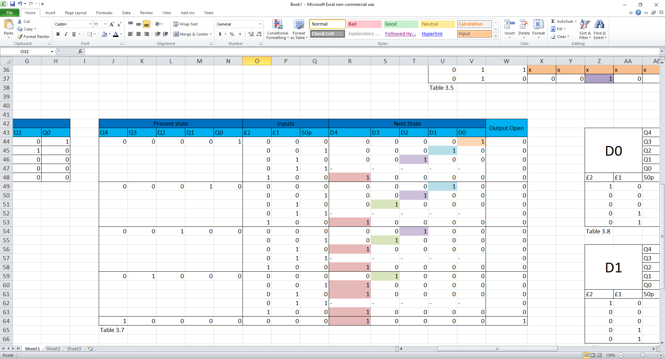

Table 3.7



Fig 3.7

Above displays the complete logic circuit for the vending machine coin sensor. This circuit is lacking a system that would allow for the inclusion of a coin return system, if the user were to insert an amount of money more than the required amount. This system could be improved if there was a way to choose an amount of money that the machine would have to receive before releasing the item. This can be done using a button matrix that would allow the user to input the code for that specific item that they will request. An internal memory will take this code and find the item and data associated with that code, selecting the logic circuit that best fits the cost of the item.

## Conclusion Task C: -

In conclusion, a logic gate circuit has been constructed with the purpose of detecting and memorising the amount of coins and its collective value which has been inserted into the machine. This has been done using the ‘Moore’ method to create a table of the ‘current state’, the ‘inputs’ and the ‘next state’. Using this to apply the information in the ‘next state’ column to a series of Karnaugh maps, which will help to determine the boolean algebraic equation that can then be used to design the logic gate circuit. Putting all the logic gates from D2 – D0 together, including the use of a d type flip flop, and the ‘output open’ gate to construct the complete circuit.

This circuit is unable to calculate or return any change from the transaction. So, the vending machine would end up consuming the excess change consuming more than is necessary. The machine is also incapable of giving a different cost for an item or that cost being changed depending on that item.

# References: -

1. *Image used for the front page: -* Wallpaperupcom, BelleDeesse. 2019. Wallpaperupcom. [Online]. [21 October 2019]. Available from: <https://www.wallpaperup.com/26609/entertainment_music_guitars_black_white_amp_strings_tech.html>
2. Abhishek Sharma, A.S. August 19, 2019. Com/article/what-is-bleeder-resistor-and-where-it-is-used. [Online].[09 March 2020]. Available from: <https://circuitdigest.com/article/what-is-bleeder-resistor-and-where-it-is-used>
3. Tom Duncan, T.D. 1996. 11.8 Power Amplifiers - Push-pull. In:John Murray , J.M, First Edition ed Success in Electronics. England: Manish Jain - BPB Publications, pp. 146
4. Learningaboutelectronicscom, 2018. Learningaboutelectronicscom/Articles/Capacitive-voltage-dividerphp. [Online].[09 March 2020]. Available from: <http://www.learningaboutelectronics.com/Articles/Capacitive-voltage-divider.php>
5. Tom Duncan, T.D. 1996. 11.8 Power Amplifiers - Push-pull. In:John Murray , J.M, First Edition ed Success in Electronics. England: Manish Jain - BPB Publications, pp. 146
6. Edward Hughes, E.H. 2008. Passive Filters - Chapter 17. In:John Hiley , J.H, Keith Brown , K.B& Ian McKenzie Smith , I.M.S, 10th Edition ed Hughes Electrical and Electronic Technology - 10th Edition. England: Pearson Prentice Hall, pp. pg.380